DEVELOPMENT OF A PROACTIVE DECISION SUPPORT SYSTEM FOR
KNOWLEDGE LOSS RISK ASSESSMENT AND KNOWLEDGE TRANSFER DURING ORGANIZATIONAL TRANSITIONS

Shanuka S. Jayakodi
Bachelor of Science Honours in Management Information Systems
Department of Information Systems
Faculty of Computing
NSBM Green University
Sri Lanka
October 2026

DECLARATION
I declare that the content of this undergraduate thesis titled 'Development of a Proactive Decision Support System for Knowledge Loss Risk Assessment and Knowledge Transfer During Organizational Transitions' is my own work and does not incorporate, without acknowledgement, any material previously submitted for any other degree in any university or institution of higher learning.
Signature: ____________________ Name: Shanuka S. Jayakodi Date: ____________________
Supervisor signature: ____________________ Name: ____________________ Date: ____________________

ACKNOWLEDGEMENT
I sincerely thank my supervisor, the academic staff of the Faculty of Computing, and all participants who contributed expert comparisons and system-evaluation feedback. I am also grateful to my family and colleagues for their encouragement throughout this research.

ABSTRACT
Employee transitions can disrupt important work when specialized knowledge is concentrated in one person and suitable documentation or backup staff are unavailable. This study developed KnowledgeGuard, a web-based decision support prototype for assessing knowledge-loss risk and coordinating knowledge transfer. Following a design science approach, the system assesses expertise uniqueness, documentation gap, project criticality, collaboration dependency, and tenure. It combines an indicator-based score with manager assessment and a supporting machine-learning score. Managers can initiate a structured knowledge-transfer plan for cases classified as high or critical risk.
The prototype was demonstrated using 30 anonymised standalone assessment responses from industry colleagues and a separate generated Q1-Q4 workflow dataset. Ten system evaluators gave a mean System Usability Scale score of 89.50 (SD = 3.07); mean perceived usefulness, ease of use and behavioural intention were 4.43, 4.53 and 4.60. An exploratory aggregation of ten pairwise responses produced a consistent AHP group matrix (CR = 0.0822), but proposed weights different from the predefined baseline. The baseline remained active for all reported scoring demonstrations. These results support prototype functionality and favourable descriptive feedback, not predictive validity or measured reduction of knowledge loss.
KnowledgeGuard demonstrates how risk assessment can be linked to managed knowledge-transfer activities. The generated assessments are not observations from a real organization, and the evaluation does not establish predictive accuracy or lasting knowledge retention. Organizational assessments over time are needed to evaluate those outcomes.

TABLE OF CONTENTS

DECLARATION ii
ACKNOWLEDGEMENT iii
ABSTRACT iv
TABLE OF CONTENTS v
LIST OF FIGURES ix
LIST OF TABLES x
LIST OF ABBREVIATIONS xii
1. INTRODUCTION 1
1.1 Chapter overview 1
1.2 Background 1
1.3 Problem statement 2
1.4 Research gap 2
1.5 Research questions 3
1.6 Research motivation and significance 3
1.7 Scope 4
1.8 Overview of the proposed solution 5
1.9 Chapter summary 7
2. OBJECTIVES 8
2.1 General objective or aim 8
2.2 Specific objectives 8
2.3 How the objectives guide the thesis 9
2.4 Chapter summary 9
3 LITERATURE REVIEW 10
3.1 Chapter overview 10
3.2 Domain concepts and theories 10
3.2.1 Organizational knowledge, tacit knowledge and knowledge-loss risk 12
3.3 Existing studies, systems or frameworks 12
3.3.1 Repositories versus proactive decision support 12
3.3.2 Limitations of self-reported assessment data 13
3.3.3 The gap between risk identification and mitigation 13
3.3.4 Comparison with related systems and frameworks 14
3.4 Technical approaches 15
3.4.1 Operationalization of knowledge-loss indicators 15
3.4.2 Transparent weighted scoring and AHP 16
3.4.3 Supporting machine learning and anomaly review 17
3.4.4 Generative AI and knowledge-transfer planning 17
3.4.5 Design-science evaluation, SUS and TAM 18
3.5 Research gap and implications for this work 18
3.6 Chapter summary 19
4. METHODOLOGY 20
4.1 Research design 20
4.2 Data, participants and stakeholders 20
4.3 Requirements and analysis 22
4.4 Proposed design 24
4.4.1 Components and data flow 24
4.4.2 From survey answer to indicator 30
4.4.3 Combining the three scores 32
4.4.4 From risk review to knowledge transfer 36
4.5 Development and implementation procedure 38
4.6 Evaluation plan 38
4.7 Ethics and project management 41
4.8 Chapter summary 42
5. RESULTS 43
5.1 Chapter overview 43
5.2 Final data and evaluation setting 43
5.3 Developed artefact and analytical outputs 44
5.3.1 Simulated knowledge-transfer trace 46
5.4 Functional and implementation evidence 47
5.5 Evaluation results 49
5.6 Results by objective 51
5.7 Chapter summary 52
6. DISCUSSION AND CONCLUSIONS 53
6.1 Discussion of key findings 53
6.1.1 Answers to the research questions 53
6.2 Comparison with literature 54
6.3 Contribution and practical implications 54
6.4 Limitations 55
6.5 Future work 56
6.6 Conclusions 57
REFERENCES 58
APPENDICES 61
Appendix A: Assessment questionnaire and indicator mapping 62
Appendix B: AHP expert-comparison instrument and calculation 64
Appendix C: System Usability Scale and Technology Acceptance Model instruments 65
Appendix D: Functional test scenarios and evidence 66
Appendix E: System demonstration protocol and supplementary interface evidence 68
Appendix F: Participant information consent and data handling 70
Appendix G: Reproducibility and evidence manifest 71

LIST OF FIGURES
Figure 1.1: Overview of the proposed KnowledgeGuard workflow
Figure 3.1: Literature themes and their design implications for KnowledgeGuard
Figure 4.1: KnowledgeGuard architecture and principal data flows
Figure 4.2: Class diagram and principal data relationships in KnowledgeGuard.
Figure 4.3: Use-case diagram for role-based KnowledgeGuard interactions
Figure 4.4: Activity diagram for assessment, validation and knowledge transfer
Figure 4.5: Supporting machine-learning score process
Figure 4.6: Sequence diagram for risk assessment and manager validation
Figure 4.7: Sequence diagram for knowledge-transfer plan completion and sign-off
Figure 5.1: Preliminary assessment before manager validation
Figure 5.2: Manager-validated assessment outcome
Figure 5.3: Knowledge-transfer plan creation and backup safeguards
Figure 5.4: Five-stage knowledge-transfer plan execution
Figure 5.5: Controlled rejection of an inconsistent AHP matrix
Figure 5.6: Quarterly score history from the generated workflow dataset
Figure 5.7: Aggregate System Usability Scale result
Figure 5.8: Technology Acceptance Model construct means

LIST OF TABLES
Table 1.1: Scope and evidence boundaries
Table 3.1: Related systems and frameworks compared with KnowledgeGuard
Table 3.2: Literature basis for the KnowledgeGuard indicators
Table 4.1: Data sources and permitted interpretation
Table 4.2: Stakeholders and their role in the workflow
Table 4.3: Functional requirements and observable checks
Table 4.4: KnowledgeGuard indicators and initial weights
Table 4.5: Supporting machine-learning component
Table 4.6: Configured operational risk tiers
Table 4.7: Evaluation measures and evidence required
Table 4.8: Quarterly assessment questionnaire design
Table 5.1: Final evaluation setting
Table 5.2: Simulated knowledge-transfer score trace
Table 5.3: Core functional test results and implementation evidence
Table 5.4: Baseline and exploratory AHP group weights
Table 5.5: System-evaluation questionnaire summaries
Table 5.6: Saved machine-learning metrics and interpretation
Table 5.7: Results by objective
Table A.1
Table B.1
Table B.2
Table C.1

LIST OF ABBREVIATIONS
AHP Analytic Hierarchy Process
API Application Programming Interface
CI Consistency Index
CR Consistency Ratio
CSV Comma-Separated Values
DSS Decision Support System
EU Expertise Uniqueness
DG Documentation Gap
PC Project Criticality
CD Collaboration Dependency
KT Knowledge Transfer
ML Machine Learning
SUS System Usability Scale
T Tenure
TAM Technology Acceptance Model

1. INTRODUCTION

1.1 Chapter overview
This chapter introduces the problem of knowledge loss during employee transitions and explains why an assessment linked to knowledge-transfer action is needed. It presents the problem, research gap, questions, significance, scope, and proposed solution.

1.2 Background
Organizations depend on knowledge held in documents, systems, work routines, and employees’ experience. Some knowledge can be recorded as instructions. Other knowledge develops through practice and judgement and may be difficult to express fully in a document. The distinction between explicit and tacit knowledge helps explain why access to documentation does not always enable another employee to perform a specialist’s work [1].
Resignation, retirement, role change, or extended absence can create a continuity risk. Its importance depends on the knowledge involved, the available documentation, the work supported by the employee, and whether another person can take over the relevant tasks. Organizational knowledge transfer requires knowledge to become usable by other people, beyond merely storing information [2].
A systematic review of 74 studies distinguished knowledge-loss drivers, effects, and mitigation, finding that much published work addresses losses already under way [3]. Recent case studies also link disruption to weak sharing of personal knowledge and show that job shadowing can form part of retention practice [4]. These findings justify looking for exposed work before a transition and specifying who will receive and practise the knowledge; they do not establish the prevalence of this problem in the demonstration dataset.
KnowledgeGuard is a decision support prototype designed to identify cases requiring attention, present assessment information for manager review, and coordinate action involving a knowledge holder and a backup employee. Its risk score summarizes defined indicators. It does not directly measure the probability of departure or actual future knowledge loss.

1.3 Problem statement
Organizations may struggle to identify which employee transitions require urgent knowledge-transfer preparation. Relevant information can be spread across employees, managers, documents, and operational processes. A manager may know that an employee is important yet lack a consistent way to assess why the employee’s absence would cause difficulty or whether a backup is ready.
Specialized expertise may be concentrated in one person while instructions remain incomplete. Project importance, dependency, and replaceability can vary independently. An assessment must therefore consider more than tenure or departure status. Automated scoring can apply the same rules across cases, but a manager may know circumstances absent from recorded responses. Identifying a risk is also only the start: a response requires transfer activities and an assessment of backup competence.
Research on knowledge loss identifies workforce transitions, limited knowledge sharing, and inadequate retention practices as sources of organizational exposure [3], [4]. These findings support the need for a structured assessment linked to transfer preparation.
The central problem is how a decision support system can help identify employee-level knowledge-loss risk and support structured knowledge-transfer decisions during organizational transitions.

1.4 Research gap
Existing research explains knowledge-loss risks and identifies retention practices, including documentation, knowledge sharing, and job shadowing [3], [4], [5]. However, these findings do not by themselves demonstrate how an employee-level assessment can be connected to manager review, assigned transfer activities, and documented assessment of backup competence within one evaluated application. This study investigates that integration through the KnowledgeGuard prototype.
The study addresses this design and integration opportunity. It does not claim to invent a theory of knowledge transfer or establish that no existing product has similar functions. Its contribution is the design, implementation, and limited evaluation of KnowledgeGuard as a particular response to the defined problem.
In design science, a working artefact and its evaluation need to be described clearly [6]. Here the artefact is the implemented assessment-to-transfer workflow; the design insight concerns how to link explainable indicators, review, and assigned transfer tasks under explicit evidence limits.
The gap is practical and evaluative as well as technical. Research identifies useful transfer mechanisms but shows that sector and work context shape retention [5]; a generic score therefore needs local testing. This project tests whether the activities can be joined into a traceable prototype, while leaving outcome validation for a future organizational study.

1.5 Research questions
The main research question is: How can a decision support system help identify employee-level knowledge-loss risk and support structured knowledge-transfer decisions during organizational transitions?
- RQ1. How can literature-informed indicators of employee-level knowledge-loss risk be operationalized in a structured prototype assessment?
- RQ2. How can indicator-based assessment, manager judgement, and supporting machine-learning analysis be integrated into a decision support workflow?
- RQ3. How can the system support the planning, completion, and review of knowledge-transfer activities after a high-risk case is identified?
- RQ4. How usable and acceptable is the prototype to its evaluators, and which aspects of its intended workflow can be demonstrated through testing?

1.6 Research motivation and significance
The practical motivation is to help managers identify important knowledge dependencies before a transition disrupts work. A structured assessment can make the reasons for prioritization visible; a linked transfer plan can direct attention to documentation, observation, discussion, and practice. The system remains a support for human judgement rather than an autonomous employment decision.
The research significance lies in examining whether established methods can be connected into one auditable workflow. Design science research supports building and evaluating an information-system artefact in response to a practical problem [6]. The value demonstrated in this study concerns the prototype and its evaluated functions; it is not evidence of long-term organizational impact.

1.7 Scope
KnowledgeGuard assesses employee-level knowledge-loss risk using five indicators: expertise uniqueness, documentation gap, project criticality, collaboration dependency, and tenure. These dimensions define the study boundary; their theoretical basis and measurement are explained in Chapters 3 and 4. The prototype combines an indicator-based score, manager judgement, and a supporting machine-learning score. It supports knowledge-transfer planning for employees classified as high or critical risk, including assigned activities, knowledge-holder and backup confirmations, managerial approval, and review through a later separately imported assessment.
The study covers prototype development and evaluation using 30 anonymised, standalone Q1 assessments and self-reported start dates from colleagues employed in industry; a separate generated Q1-Q4 dataset for workflow testing; ten expert pairwise-comparison responses; and ten system-evaluation responses. The prototype was deployed online for evaluator access, not as a partner-organization field study. AHP supplied an exploratory comparison with the predefined weights; it did not change the scoring configuration used in the evaluation.
The colleague responses do not constitute a representative organizational sample, and the generated Q1-Q4 dataset does not represent observations of real employees over four quarters. The evaluation therefore addresses prototype functionality, usability, and perceived acceptance; it does not establish independent real-world predictive accuracy, lasting knowledge retention, or an actual reduction in organizational knowledge loss. Risk classifications support managerial review and knowledge-transfer prioritization. Further organizational evaluation would be required to assess sustained transfer outcomes.
Table 1.1: Scope and evidence boundaries
Included in this study | Outside the demonstrated evidence
Prototype assessment and manager-reviewed KT workflow | Deployment or observed outcomes in a partner organization
Standalone colleague responses and a separate generated Q1-Q4 test dataset | A real four-quarter cohort or observed retention over time
Exploratory AHP comparisons and usability responses | Validated indicator weights or population-wide acceptance
Scoring and functional demonstration | Independent prediction of departures or knowledge loss

1.8 Overview of the proposed solution
The workflow begins with structured assessment responses, which are processed into indicator scores and risk information for managerial review. A case needing attention may lead to a plan involving the knowledge holder, backup, and manager. The plan organizes documentation, shadowing, a structured interview, backup competence assessment, and final sign-off. Later assessments can support review of changes in calculated risk. Figure 1.1 summarizes the assessment, managerial review, knowledge-transfer, and reassessment workflow.
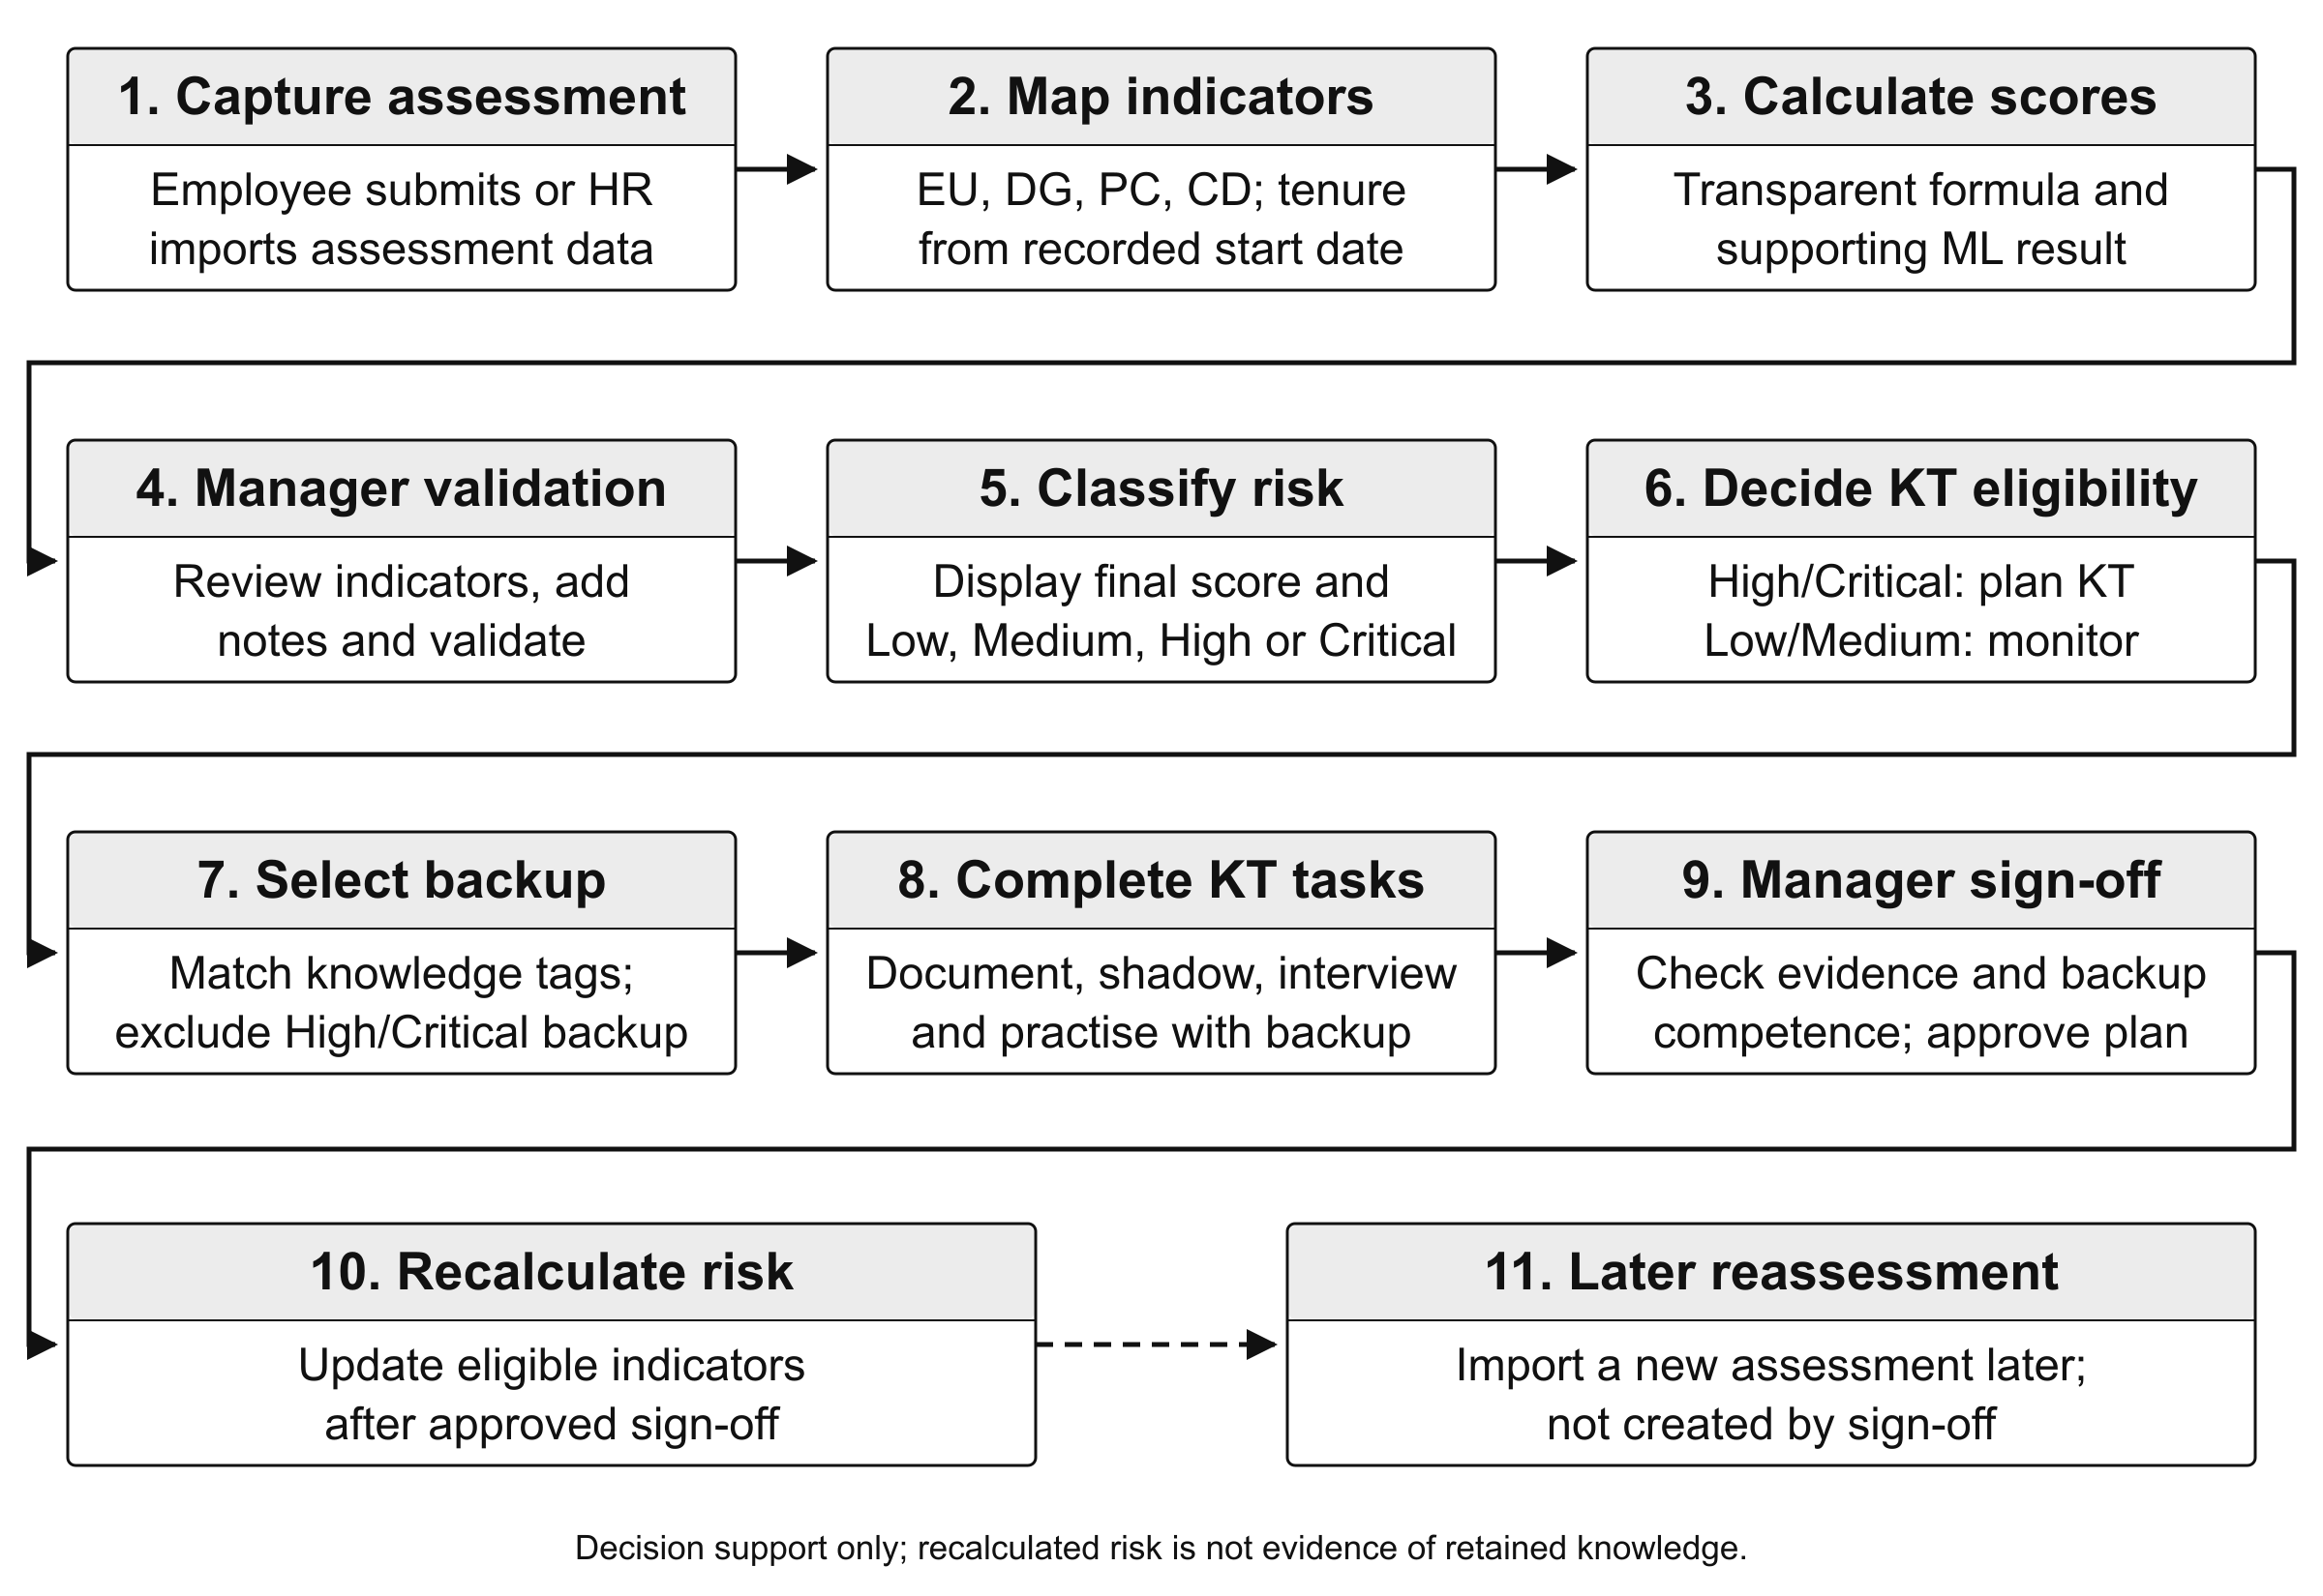
Figure 1.1: Overview of the proposed KnowledgeGuard workflow.

1.9 Chapter summary
This chapter defined the knowledge-loss problem, the study’s design contribution, four research questions, and the boundaries of the prototype evaluation. Chapter 2 states the objectives, and Chapter 3 reviews the research informing the assessment and transfer workflow.

2. OBJECTIVES

2.1 General objective or aim
The aim of this research was to design, develop, and evaluate KnowledgeGuard, a proactive decision support prototype that helps assess employee-level knowledge-loss risk and supports knowledge-transfer decisions during organizational transitions. The study therefore had three connected tasks: define an explainable assessment, implement an assessment-to-transfer workflow, and evaluate the prototype's functions and perceived usability and acceptance.
KnowledgeGuard was designed to present assessment inputs and risk information for manager review, connect eligible cases to assigned transfer activities, and retain evidence of review and approval. The aim concerns decision support, not an autonomous employment decision. The available evaluation can show how the prototype works and how its evaluators perceived it; it cannot show that the system predicts departures or prevents future knowledge loss.

2.2 Specific objectives
- Objective 1. To identify literature-informed indicators of employee-level knowledge-loss risk and operationalize them in a measurable assessment with rule-based response-quality checks for managerial review.
- Objective 2. To critically compare relevant knowledge-management, knowledge-risk assessment, workforce-analytics, and decision-support approaches, and derive justified requirements for a proactive assessment-to-transfer prototype.
- Objective 3. To design and implement KnowledgeGuard as an integrated workflow combining transparent risk scoring, manager validation, supporting machine-learning analysis, knowledge-transfer planning, participant confirmation, competence review, and sign-off.
- Objective 4. To verify the prototype's assessment and knowledge-transfer functions through functional tests and system records, and describe evaluator-perceived usability and acceptance using the System Usability Scale (SUS) and Technology Acceptance Model (TAM) responses.

3. LITERATURE REVIEW

3.1 Chapter overview
This chapter reviews the literature and concepts that inform KnowledgeGuard, a decision-support prototype for identifying employee-level knowledge-loss risk and supporting knowledge-transfer planning. The review begins with organizational knowledge, tacit knowledge, and the risks created when important knowledge is concentrated in individual employees. It then examines the limitations of existing knowledge-management approaches, particularly document repositories, self-reported assessments, and approaches that identify risk without supporting follow-up transfer activities.
The chapter next explains the design basis for KnowledgeGuard: the five risk indicators, transparent weighted scoring, Analytic Hierarchy Process (AHP), response-quality checks, supporting machine learning, generative AI assistance, and knowledge-transfer activities. Finally, it synthesizes the literature to define the research gap addressed by the prototype.

3.2 Domain concepts and theories
The review connects three bodies of evidence: concepts of organizational knowledge and loss; studies and systems addressing retention, assessment, and succession; and methods for scoring, transfer support, and prototype evaluation. Figure 3.1 summarizes how these streams inform the design choices examined in this study.
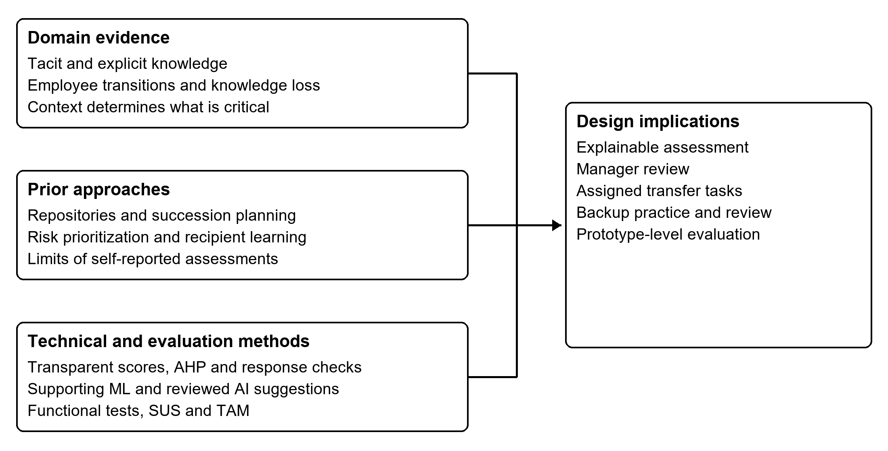
Figure 3.1: Literature themes and their design implications for KnowledgeGuard.

3.2.1 Organizational knowledge, tacit knowledge and knowledge-loss risk
Organizational knowledge includes documented information, work routines, practical experience, technical skills, judgement, and contextual understanding used to perform work. Knowledge management concerns the creation, capture, sharing, retention, and application of this knowledge.
A central distinction is between explicit and tacit knowledge. Explicit knowledge can be documented and communicated through manuals, procedures, reports, system records, and policies. Tacit knowledge is more closely connected to personal experience, judgement, practical skill, and context [1]. An organization may retain documents after an employee leaves but still lose the ability to solve unusual problems, understand historical decisions, or perform work efficiently.
Employee transitions such as resignation, retirement, internal transfer, promotion, restructuring, or extended absence can create knowledge-loss exposure. The risk may be greater when specialized expertise is concentrated in one person, documentation is incomplete, critical work depends on that person, or colleagues frequently rely on them for support [3], [4], [7]. KnowledgeGuard treats knowledge loss as a proactive assessment and decision-support problem. It does not predict whether an employee will resign; it identifies cases where an absence could create difficulty and where transfer preparation may be appropriate.
A high risk score is not evidence that knowledge has already been lost. It is an indication that the case should be reviewed. Similarly, a completed transfer plan records workflow completion but does not independently prove that a backup employee will retain and apply the knowledge over time.

3.3 Existing studies, systems or frameworks

3.3.1 Repositories versus proactive decision support
Knowledge repositories and collaboration systems, such as SharePoint and Confluence, are valuable for storing documents, sharing information, and maintaining recorded knowledge [8], [9]. ServiceNow Knowledge Management also supports controlled publication and approval of knowledge articles [10]. However, repositories primarily manage knowledge that has already been captured. They do not inherently identify which employee has difficult-to-replace knowledge, determine the operational consequences of that employee's absence, or initiate a knowledge-transfer workflow from a risk assessment.
This does not mean that repository systems are ineffective. They can support KnowledgeGuard by storing documentation created during transfer activities. The limitation is that document storage alone does not provide proactive employee-level risk assessment or confirm that a backup employee can perform the relevant work.

3.3.2 Limitations of self-reported assessment data
Structured assessments, spreadsheets, and survey platforms can collect useful employee-level information. However, self-reported answers may contain response-quality issues, such as limited variation, inconsistent interpretation, or potentially self-enhancing answers. Ward and Meade recommend prevention, screening, and transparent reporting when handling potentially careless survey responses [11].
A straight-lined or contradictory response does not prove dishonesty. It may reflect misunderstanding, limited differentiation between questions, or other circumstances that require follow-up. KnowledgeGuard therefore presents low-variation, contradictory, and potentially self-enhancing response patterns as review flags rather than labels of employee intent. Its rule-based checks are not a validated lie-detection method.

3.3.3 The gap between risk identification and mitigation
A risk score alone does not transfer knowledge. Once a potentially high-risk case is identified, a manager must still determine what knowledge requires transfer, who is a suitable backup employee, which activities should be completed, and whether the backup has practised the work.
Research on knowledge transfer supports documentation, observation, interaction, practice, and recipient involvement rather than relying only on static documents [2], [12], [13]. KnowledgeGuard therefore links assessment to a manager-reviewed knowledge-transfer workflow: assessment, risk information, manager review, KT planning, documentation, shadowing, interview, practice, sign-off, and later reassessment.
The evidence also limits what a completed transfer activity can mean. Sumbal et al. examined critical knowledge areas, likelihood of loss, and future relevance in one manufacturing setting [14]. Biron et al. studied 81 matched groups of retiring employees, supervisors, and successors, finding that the usefulness of transferred knowledge for successors depended partly on supervisory behaviour [13]. These studies support attention to context, manager involvement, and the recipient's ability to use knowledge. Their settings do not validate KnowledgeGuard's scores or establish that its task completion measures lasting retention.

3.3.4 Comparison with related systems and frameworks
Table 3.1 compares selected documented functions with the problem addressed by KnowledgeGuard. For example, SAP's succession workflow includes manager assessments of risk and impact of loss alongside successor development [15]. The table is a source-based comparison, not a hands-on benchmark or a claim that the products lack other configurable functions.

Table 3.1: Related systems and frameworks compared with KnowledgeGuard
Example | Main documented focus | Relationship to KnowledgeGuard
SharePoint [8] | Collaborative file storage and versioning | May store KT documentation; employee-level risk and recipient competence are outside this comparison's tested scope
Confluence [9] | Shared pages, attachments, and team knowledge | May store process knowledge and KT notes; no hands-on product evaluation was conducted
ServiceNow Knowledge Management [10] | Knowledge-article governance and approval | Related approval capability; different assessed object
APQC Knowledge Loss Risk Matrix [16] | Prioritizing knowledge areas exposed to loss | Comparable prioritization concept; detailed matrix not publicly available
SAP SuccessFactors [15] | Successor identification and readiness | Supports succession and talent continuity; its configurable risk and development functions were not tested here
KnowledgeGuard | Employee-level assessment, manager review, KT tasks, backup practice, and sign-off | Integrated prototype workflow; organizational impact remains unvalidated

The reviewed systems may be configured or combined differently by organizations. KnowledgeGuard does not claim that no other system can provide similar functionality. Its contribution is the implementation and limited evaluation of one focused assessment-to-transfer workflow.

3.4 Technical approaches

3.4.1 Operationalization of knowledge-loss indicators
KnowledgeGuard uses five indicators to represent different dimensions of employee-level knowledge-loss exposure: expertise uniqueness, documentation gap, project criticality, collaboration dependency, and tenure. The first four are derived from structured assessment responses; tenure is calculated from a recorded start date. The literature motivates the first four dimensions but does not establish this exact five-indicator model or its numerical weights as universally valid [1], [2], [17], [18], [19]. Tenure is an additional contextual proxy chosen for the prototype, not direct evidence that a long-serving employee is irreplaceable.
Table 3.2 makes the selection logic explicit. The indicators were chosen through synthesis of related evidence rather than adoption of a single validated five-factor instrument. Each indicator represents a different question that a manager may need to consider when deciding whether transfer preparation is warranted. Keeping the indicators separate also helps the system explain why a case requires review and which parts of the exposure a transfer activity can plausibly address.

Table 3.2: Literature basis for the KnowledgeGuard indicators
Indicator | Research rationale | Design implication in KnowledgeGuard
Expertise uniqueness | Knowledge concentrated in one person can be difficult to replace [17], [18] | Assess whether alternative holders can perform comparable work
Documentation gap | Tacit or inaccessible knowledge is difficult for another employee to use [1], [2] | Assess whether essential procedures and context are available in usable form
Project criticality | The consequences of loss depend on which work is affected and whether the knowledge remains relevant [4], [14], [19] | Assess the potential disruption associated with important work
Collaboration dependency | Knowledge transfer and work continuity depend on relationships and reliance on people [2], [3] | Assess how strongly colleagues depend on the holder for support or decisions
Tenure | Service length is a contextual design proxy; it does not establish unique or critical knowledge | Calculate tenure from the start date and assign it a lower researcher-defined baseline weight

The table does not claim that the five factors are exhaustive or universally sufficient. For example, an organization may later need to consider regulatory exposure, customer relationships, role scarcity, succession readiness, or transition likelihood. Those contextual matters can inform manager review and future organization-specific calibration, but they were not added to the baseline formula because the prototype required a small, explainable, consistently available set of inputs.
There is also an important distinction between selection of an indicator and validation of its numerical measurement. Literature can justify considering documentation gap or collaboration dependency, but it cannot automatically validate the exact questionnaire wording, score mapping, thresholds, or relative weight used in this prototype. Chapter 4 therefore describes these operational choices explicitly, while Chapter 5 reports only the evidence available for their implementation and evaluation.

3.4.2 Transparent weighted scoring and AHP
A transparent weighted score was selected so managers can inspect why a case receives a risk tier. KnowledgeGuard begins with researcher-defined baseline weights and combines the formula score with manager validation and a supporting ML score. These weights are design assumptions, not estimates of universal importance; Chapter 4 gives their allocation and the complete formula. Manager validation has the greatest influence in the validated result because local work context may not be captured by survey answers.
AHP provides a structured method for proposing indicator weights through pairwise comparisons and a consistency ratio (CR) that assesses coherence [20]. KnowledgeGuard uses AHP as optional calibration, not as a per-employee calculation. This study compares an aggregated expert-response matrix with the predefined baseline but does not apply its proposed weights. CR below 0.10 indicates acceptable group-matrix consistency; it does not establish that every respondent was consistent or that the weights predict organizational outcomes.
The methods serve different purposes. Weighted scoring provides a reproducible case-level explanation; AHP elicits a possible group priority ordering; manager validation adds contextual judgement. Neither an acceptable AHP consistency ratio nor a weighted score demonstrates predictive validity. The study therefore reports the expert-derived weights as a comparison while keeping the predefined configuration used to test the prototype.

3.4.3 Supporting machine learning and anomaly review
KnowledgeGuard uses a Random Forest classifier as a supporting machine-learning component. Random Forest combines multiple decision trees to classify structured data [21]. The ML service receives the five indicator values and returns a supporting risk tier and score; it cannot make an autonomous employment decision.
The default model uses synthetic profiles whose risk-tier labels are derived from the baseline formula. Its metrics therefore demonstrate reproduction of configured scoring patterns, not independent prediction of employee departure, service disruption, or knowledge loss. The system can be retrained using real manager-validated records when sufficient data are available, but independent organizational outcome labels would still be necessary to establish predictive validity.
Isolation Forest identifies observations that are relatively unusual within a dataset [22]. KnowledgeGuard uses it to generate an exploratory alert from an employee's recorded risk-score history. The current service can run with as few as three scores, so an alert from a short or generated history requires particular caution; it neither establishes the cause of a change nor proves that an employee gave false answers.

3.4.4 Generative AI and knowledge-transfer planning
Generative AI may help turn assessed risks into plain-language explanations, interview prompts, and suggestions for transfer activities [23]. Its output can be incomplete or inaccurate and can expose sensitive work information if inputs are not controlled. KnowledgeGuard therefore treats generated material as a proposal for manager review. Chapter 4 explains the implemented chat and action controls; generated text is not independent evidence that risk has fallen.
Research on transfer and recipient usefulness supports combining documentation with observation, discussion, and practice [12], [13]. Those approaches informed KnowledgeGuard's documentation, shadowing, structured interview, backup practice, competence review, and manager sign-off. Knowledge tags can guide backup nomination, but matching tags alone cannot establish readiness. The implemented eligibility rules and indicator-update procedure are specified in Chapter 4.

3.4.5 Design-science evaluation, SUS and TAM
Design Science Research supports development and evaluation of an information-system artefact intended to address a practical problem [6]. Functional testing evaluates whether KnowledgeGuard performs required actions, such as importing assessments, calculating scores, showing review flags, applying AHP consistency safeguards to submitted matrices, restricting unsuitable backups, and recording KT progress.
The System Usability Scale (SUS) measures perceived usability [24]. The Technology Acceptance Model (TAM) examines perceived usefulness, perceived ease of use, and behavioural intention [25]. Together, functional tests, SUS, and TAM provide prototype-level evidence; they do not establish organization-wide acceptance, real-world predictive accuracy, or lasting knowledge retention.

3.5 Research gap and implications for this work
The reviewed studies establish why concentrated expertise and incomplete transfer create exposure, while also showing that the usefulness of transferred knowledge depends on context and recipient capability [1], [3], [17], [12], [13]. The reviewed products address storage, prioritization, or succession, but their documented functions were not independently benchmarked in this study.
These sources justify a narrower research question: can one prototype connect an explainable employee assessment with manager review, assigned transfer work, recipient competence assessment, and a traceable later review? The literature does not validate KnowledgeGuard's particular questionnaire, weights, ML model, or transfer outcomes. Those choices must be described transparently and evaluated within the limits of the available data.
The contribution is an implemented and evaluated integration of established ideas rather than a claim that no comparable product exists. Chapter 4 specifies the design and evaluation methods used to investigate this integration; Chapter 5 reports what the prototype and its evaluators actually demonstrated.

3.6 Chapter summary
This chapter reviewed the concepts and literature informing KnowledgeGuard. It explained why employee transitions can create knowledge-loss exposure, why repositories and risk scores alone are insufficient, and why a manager-reviewed transfer workflow is required.
The chapter justified the selected indicators, transparent scoring, AHP, response-quality review, Random Forest, Isolation Forest, generative-AI assistance, and KT stages. It also clarified that response flags do not detect lies, ML provides support rather than autonomous decisions, and workflow completion does not prove long-term knowledge retention. Chapter 4 explains how the system was designed, implemented, and evaluated.

4. METHODOLOGY

4.1 Research design
This study used design science research to develop and evaluate a decision support artefact addressing a defined organizational problem [6]. The unit of design was KnowledgeGuard: an application that turns assessment responses into reviewable risk information and links selected cases to knowledge-transfer activities. The work followed problem identification, review of relevant research, requirements definition, construction, and evaluation. Iterative changes to the interface and processing logic were made during development. This method is appropriate because the research question concerns how a working system can support an assessment and response workflow, rather than testing a general causal theory of employee turnover.
Functional tests check whether the implemented workflow follows its rules; questionnaire responses describe perceived usability. Neither shows that knowledge was retained following an actual employee transition. Generated assessments therefore demonstrate operation, not field effectiveness.

4.2 Data, participants and stakeholders
Five distinct evidence sources were used. First, 30 anonymised standalone Q1 assessment responses were collected from colleagues employed in industry. Each response contained ten questionnaire items covering backup coverage, difficulty of transferring work, documentation, work criticality and dependency, with direct and reverse-worded items. These convenience responses were used to demonstrate mapping to four survey-derived indicators. Each colleague supplied a start date for the prototype tenure calculation. The responses were not supplied by a partner organization and are not a representative employee cohort.
Second, a separate generated dataset contains 30 fictional employee identities in each of Q1, Q2, Q3 and Q4: 120 generated assessment rows in total. The same fictional identities link the four test quarters for import and history demonstrations. None is linked to the 30 real colleague responses. These controlled scenarios test score history, manager validation and KT workflow; they are not observed employee follow-up.
Third, ten pairwise-comparison responses were collected for exploratory AHP analysis. The corrected importer converts the form's 1-left, 5-equal, 9-right scale to reciprocal ratios before taking geometric means across responses. The proposed group weights were not used to replace the baseline during evaluation. Fourth, ten working professionals with HR, management, technical or organizational-process experience used the deployed prototype and completed SUS and acceptance items; exact role counts and affiliations were not recorded. Fifth, saved synthetic ML metrics provide implementation evidence.
Table 4.1: Data sources and permitted interpretation
Source | Quantity or period | Purpose and status
Standalone colleague assessment CSV and manually supplied start dates | 30 anonymised colleague responses | Real prototype input for mapping, scores and tenure calculation
Separate quarterly test scenarios | Q1-Q4 | Controlled test sequence for workflow demonstration; separate from colleague responses
System-evaluation forms | 10 collected responses | Descriptive SUS and acceptance ratings
Synthetic ML training records and saved metrics | 500 generated training profiles | Supporting ML implementation evidence; not real-world prediction validation
Expert pairwise-comparison responses | 10 collected responses | Exploratory AHP group weights and consistency; not weight validation against outcomes

The application stakeholders are employees providing assessments, managers reviewing risk and transfer, HR users inspecting authorized results, backup employees participating in transfer, and administrators managing users and configuration. These roles are distinct from research respondents. The study reports aggregate questionnaire results and uses generated identities for workflow screenshots.
Table 4.2: Stakeholders and their role in the workflow
Actor | Main responsibility | Evidence or decision
Employee | Provide assessment answers and knowledge resources | Mapped responses and task submissions
Manager | Validate risk and assess backup competence | Validated scores, approvals and sign-off
Backup employee | Observe, discuss and practise the work | Confirmations and practice evidence
HR user | Import authorized responses and review permitted results | Import records and dashboard summaries
Administrator | Manage users, roles and scoring configuration | Access and configuration records

4.3 Requirements and analysis
Requirements were drawn from the practical risk-and-response problem, literature reviewed in Chapter 3, and the available project specification and implementation. The assessment needed to accept a structured CSV, map responses to four survey-based indicators, derive tenure from a stored start date, expose response-quality warnings, and retain a traceable score and tier. Because manager context is absent from the survey, the system also needed a recorded validation step. A further requirement was to protect the scoring configuration against inconsistent expert comparisons. The supplied implementation checks the submitted matrix again in the API before changing the configured weights.
KT planning requires a High or Critical holder, an eligible backup, task evidence and confirmations, competence review, and manager sign-off before recalculation. The interface uses knowledge-tag overlap to suggest backups and knowledge areas; overlap is guidance, not proof of suitability. The backend checks distinct employee accounts, the manager's team boundary, and the backup's risk tier. It rejects a High or Critical backup even if the interface is bypassed. An unscored backup is not automatically classified as high risk, which limits this safeguard.
Each requirement has a corresponding observation for evaluation: a recognized CSV should produce mapped indicators; the AHP interface should disable application of inconsistent judgements; an ineligible holder or high-risk backup should be rejected; and unfinished KT tasks should prevent sign-off. The AHP utility and interface were checked with controlled input, while direct endpoint behaviour was not recorded as an executed integration test. Screenshots illustrate visible states, source inspection identifies implemented controls, and executed tests establish only the behaviours they exercise. Chapter 5 distinguishes these evidence types.
Nonfunctional priorities included access by role, legible reasons for a score, graceful handling of an unavailable ML service, and records that permit a manager to inspect progress. These are design requirements; Chapter 5 reports what was actually tested. The extensive original use cases, detailed screen flows, and test-case scripts belong in appendices when needed. The following sections give the implemented design and the evaluation methods needed to interpret its results.
Table 4.3: Functional requirements and observable checks
Requirement | Intended behaviour | Proposed check
FR01 Assessment import | Map CSV answers to four indicators; derive tenure | Inspect mapped row and formula
FR02 Manager review | Record validated input and combine three scores | Recalculate a known example
FR03 Weight control | Reject inconsistent comparisons in UI and API | Check disabled Apply action and API 400; confirm settings unchanged
FR04 KT eligibility | Allow high or critical holder and viable backup | Try eligible and ineligible cases
FR05 KT completion | Require evidence, confirmations and competence review | Attempt premature sign-off
FR06 Service resilience | Retain scoring when ML request fails | Simulate service unavailability
FR07 Manager assistance | Show manager-scoped team risk answers and proposed actions requiring confirmation | Inspect manager chat, confirmation controls and backend role checks
FR08 Notifications | Show in-app workflow alerts; send email when configured | Inspect alert triggers and email service; record delivery only if observed

A representative use case begins when an authorized user imports a questionnaire CSV, checks mapping and quality warnings, and opens an employee's preliminary score. A manager can validate the assessment and record a note. A current High or Critical tier permits KT-plan creation, nomination of an eligible backup, and five assigned tasks. Participants submit evidence and confirmations; the manager reviews competence and closes a completed plan. A separate import is required to create a later-quarter assessment. Manager validation is an important intended step, but the current plan-creation API checks the latest tier rather than enforcing a manager-validation flag.

4.3.1 Non-functional requirements
Non-functional priorities were role-based access, visible scoring rules, continued formula scoring when ML is unavailable, usable manager review, and maintainable separation of the interface, application server, database and ML service. The evaluation used anonymised or generated inputs. The chatbot sends current team summaries to an external AI provider, and email delivery can include an employee name and risk tier. Organizational use would therefore require approved data sharing, access controls and retention rules. No penetration, load or organizational privacy audit was completed.

4.4 Proposed design

4.4.1 Components and data flow
KnowledgeGuard comprises a React/Vite interface, a Node.js/Express application layer, MongoDB accessed through Mongoose, and a separate Python/FastAPI service. The backend coordinates imports, authentication and role checks, scoring, KT tasks, and communication with the ML and generative-AI services. This separation allows the assessment workflow to remain under application control even when a supporting service is unavailable. Assessment, risk-score, employee, KT-plan, and KT-task records connect an imported response with later review and action.
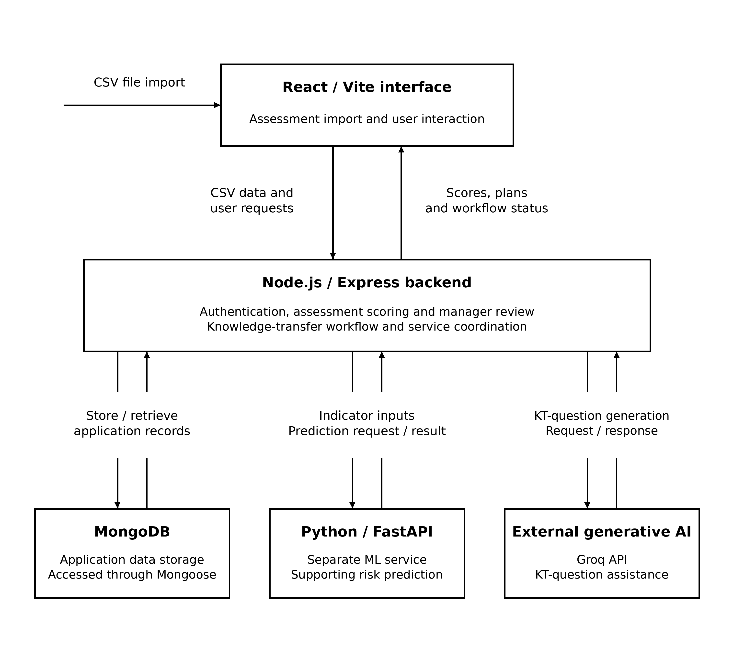
Figure 4.1: KnowledgeGuard architecture and principal data flows.

Figure 4.1 shows the separation between the user interface, application layer, data store, ML service, and generative-AI service. The Node.js/Express backend coordinates access to these components and keeps scoring, authorization, and KT workflow rules under application control. This architecture supports transparent risk processing while allowing the application to use fallback behaviour when an external supporting service is unavailable.

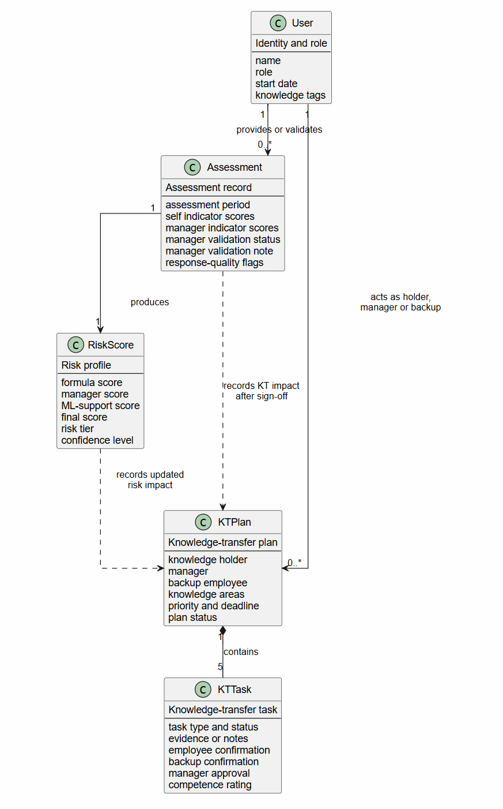
Figure 4.2: Class diagram and principal data relationships in KnowledgeGuard.
Figure 4.2 represents the principal records that provide traceability from assessment input to knowledge-transfer evidence. An assessment is associated with an employee and produces risk information that can be reviewed by a manager. An eligible employee may then be associated with a KT plan and its task records, which retain confirmations, evidence, competence review, and sign-off status. The diagram is a conceptual class/data-model view; it does not imply a relational database design or expose implementation-only fields.

Below Figure 4.3 identifies the responsibilities supported by KnowledgeGuard. Employees provide assessment information and complete assigned transfer activities. Managers review risk information, validate assessments, create and approve transfer plans, assess backup competence, and sign off completed plans. Backup employees participate in transfer activities and confirm sessions. HR users import authorised assessment data, view AHP consistency information, and export authorised evaluation data, while administrators manage users, roles, and AHP settings. The diagram therefore represents a role-based decision-support system, not an autonomous employment-decision system.

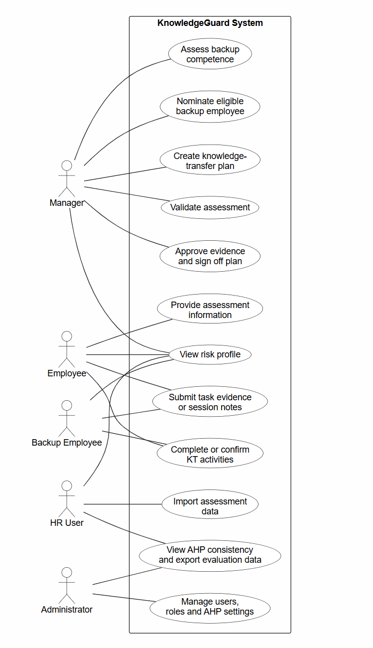
Figure 4.3: Use-case diagram for role-based KnowledgeGuard interactions.
[Insert corrected Figure 4.4 activity diagram here]
Figure 4.4: Activity diagram for assessment, validation and knowledge transfer.
Figure 4.4 summarizes assessment input, preliminary scoring, optional manager validation, KT planning for a current High or Critical tier, task completion, sign-off, score recalculation, and separately imported later assessment. Manager review is the intended decision process; the present API does not make a validation flag a precondition for plan creation. The activity diagram must retain an unvalidated profile as preliminary rather than implying automatic validation.

4.4.2 From survey answer to indicator
The parser maps each recognized questionnaire option to a score, using a higher value for greater reported exposure, and groups the resulting values by indicator. The four survey-based indicators are expertise uniqueness (EU), documentation gap (DG), project criticality (PC), and collaboration dependency (CD). The fifth indicator, tenure (T), uses service-length bands calculated from the stored start date rather than the survey answer. The defined default formula is F = 0.25(EU) + 0.20(DG) + 0.20(PC) + 0.20(CD) + 0.15(T).
Table 4.4 records the meaning, source, and provisional weight of each component. These definitions describe assessment inputs rather than independent measures of a future loss event.
Table 4.4: KnowledgeGuard indicators and initial weights
Indicator | What the score represents | Source | Weight
EU | Few alternative holders of specialist work | Mapped employee survey | 0.25
DG | Inadequate documentation for essential tasks | Mapped employee survey | 0.20
PC | Consequences for important project work | Mapped employee survey | 0.20
CD | Other work depends on the holder | Mapped employee survey | 0.20
T | Service length according to stored start date | Calculated from personnel record | 0.15
The baseline weights are transparent researcher-defined prototype settings informed by literature, not estimated effects. Expertise uniqueness receives 0.25 because concentrated specialist knowledge is difficult to replace [17], [18]. Documentation gap, project criticality and collaboration dependency each receive 0.20 because they represent distinct exposures without evidence for a stronger ordering [1], [2], [19]. Tenure receives 0.15 as context rather than proof of irreplaceability. The percentages sum to 1.00. The later exploratory AHP group result differs from this baseline; it was reported, not applied, so all evaluated scores retain the predefined configuration.
For example, the Q1 question about how many colleagues can complete an employee’s complex deliverables contributes to expertise uniqueness. An answer indicating that nobody else can do so maps to a high indicator value; an answer indicating several capable colleagues maps to a lower value. Questions vary across the generated quarters, but the parser assigns the recognized answers to the same four indicator categories. This design enables a repeated assessment while changing the wording and work context of individual questions. The generated demonstration cannot by itself establish that the quarterly questionnaires measure these concepts equivalently in an organization.
For Q1-style responses, the parser examines variation across mapped items and checks direct against reverse-worded items. Fewer than four mapped responses do not trigger its standard-deviation check. Where the mapped scores have a standard deviation below 1.0, the system flags a straight-lining pattern and adjusts its confidence handling. A warning invites scrutiny; it is not a determination that an employee gave dishonest responses. The confidence discount is not directly subtracted from the numerical final score in the supplied scoring function.
The system offers AHP calibration of five indicator weights [20]. For raw form responses, the importer maps answers 1-9 to left/right ratios 9, 7, 5, 3, 1, 1/3, 1/5, 1/7 and 1/9, respectively; it then takes the geometric mean for each of ten named comparisons and forms a reciprocal 5 x 5 matrix. The component derives proposed weights from column-normalized row means, estimates lambda_max and calculates CI = (lambda_max - 5)/4 and CR = CI/1.12. The interface permits Apply only for CR < 0.10, and the API independently rejects CR at or above 0.10 without changing settings. A consistent proposal is not applied automatically. The study retained the baseline for scoring comparisons, and group consistency was not treated as predictive validation.

4.4.3 Combining the three scores
Table 4.5 makes the supporting machine-learning component explicit. The model supports, rather than replaces, the transparent formula and the manager's validation decision.

Table 4.5: Supporting machine-learning component
Element | Implemented choice | Evidence or output | Interpretation
Algorithm | Random Forest classifier: 100 trees, maximum depth 6, minimum split 5, balanced classes, seed 42 | RandomForestClassifier configuration | A non-linear supporting classifier, not an autonomous decision-maker
Inputs | EU, DG, PC, CD and tenure, each validated on a 1-10 scale | Prediction request validation | Uses the same indicators available to the formula
Default training data | 500 synthetic feature profiles labelled by the configured formula and tiers | Model metrics identify source as synthetic | No independent employee departure or retention outcome is predicted
Prediction | Tier probabilities mapped to fixed midpoints: low 1.5, medium 4.3, high 6.5, critical 8.8 | Probability-weighted supporting score | Produces a continuous ML support score alongside the tier
Internal evaluation | Five-fold stratified cross-validation when class counts permit | Saved synthetic-data metrics reported in Chapter 5 | Internal rule-reproduction estimate, not field predictive validity
Explainability | Feature-importance values recorded for the saved model | Saved metrics endpoint; numerical values reported in Chapter 5 | Synthetic-model association, not causal evidence
Resilience | Formula score substitutes when the ML service is unavailable | Backend scoring path | Risk assessment remains available without the ML service

Once an assessment is available, the backend computes F from employee-derived inputs. A manager-validated indicator set yields a separate manager formula score M. The FastAPI endpoint returns a supporting score L using a Random Forest classifier trained, by default, on 500 synthetic profiles labelled by the predefined formula [21]. Its class probabilities are converted to a numerical score using tier midpoints. After manager validation, the final score is R = 0.30F + 0.50M + 0.20L. Before validation, R = 0.70F + 0.30L. If the ML request fails, F substitutes for L, while a validated manager score still retains its 50% contribution. Numerical results are rounded and assigned low (up to 5.0), medium (above 5.0 to 7.5), high (above 7.5 to 9.0), or critical (above 9.0). These are prioritization tiers; they do not represent measured probabilities of departure.
The saved model evaluated here was trained on 500 synthetic profiles. Each label was a tier calculated from the baseline formula, so the classifier's measured performance shows how well it reproduces that configured rule. KnowledgeGuard can also retrain from real manager-validated assessment records: the route extracts the same five features, creates a label from the manager-scored formula, and ordinarily requires at least ten usable records from at least two tiers. This capability was not used for the reported model. Manager-derived labels remain assessment judgements; independent observed continuity outcomes would be needed to test prediction of actual knowledge loss.
Table 4.6: Configured operational risk tiers
Tier | Final score R | Workflow interpretation
Low | R ≤ 5.0 | Record assessment and review as needed
Medium | 5.0 < R ≤ 7.5 | Review exposure and supporting evidence
High | 7.5 < R ≤ 9.0 | Eligible holder for KT planning
Critical | R > 9.0 | Eligible holder for KT planning
A worked test case illustrates the arithmetic. With EU = 9, DG = 8, PC = 9, CD = 7, and T = 10, the default formula gives F = 0.25(9) + 0.20(8) + 0.20(9) + 0.20(7) + 0.15(10) = 8.55. The saved default model contains low, medium and high classes only, so its configured probability-weighted score cannot exceed the high-tier midpoint of 6.50. Using a manager score of 8.50 and the maximum currently possible ML score of 6.50 gives R = 0.30(8.55) + 0.50(8.50) + 0.20(6.50) = 8.115, rounded to 8.12 (high). This is an arithmetic demonstration using the current model's stated output boundary, not a captured organizational prediction. Chapter 5 reports the outputs actually supported by its demonstration evidence.
The Python service also offers Isolation Forest analysis of a supplied score history when at least three points are available [22]. This checks whether the latest score is unusual relative to the submitted series. It differs from the Node.js check for low-variation answers within one questionnaire, and it cannot identify why a score changed. Historical data in the present demonstration do not constitute longitudinal evidence from an organization.

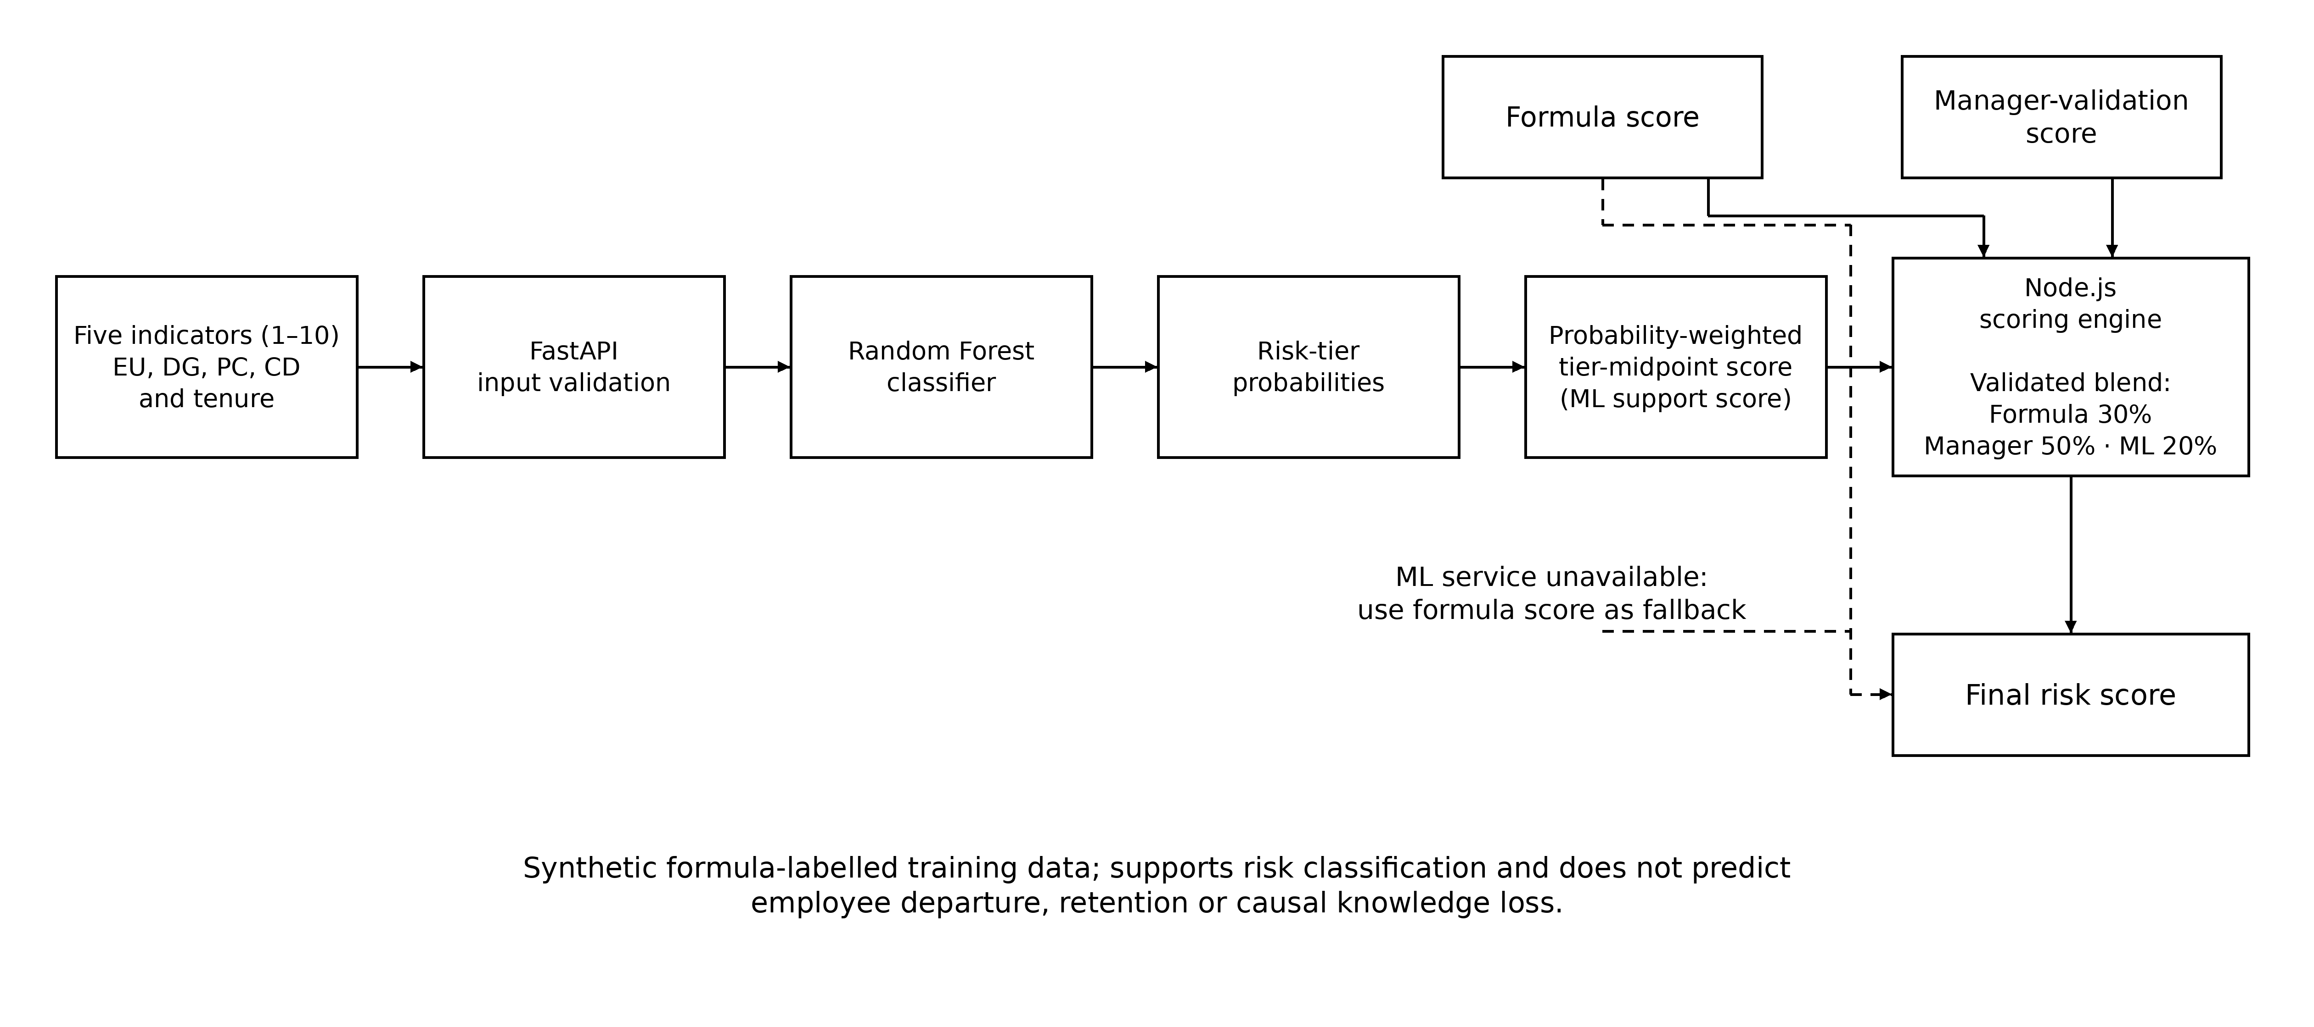
Figure 4.5: Supporting machine-learning score process in KnowledgeGuard.

Figure 4.5 makes the supporting role of machine learning visible. The Random Forest receives the same five indicator values used by the formula, returns tier probabilities, and produces a probability-weighted support score. The final scoring engine still uses the transparent formula and, after validation, manager judgement. The fallback path ensures that a risk assessment remains available if the ML service is unavailable.
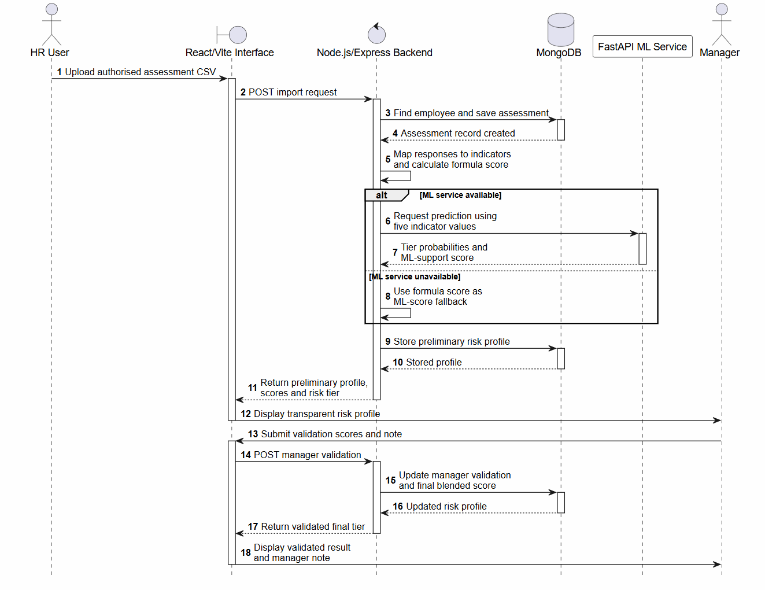
Figure 4.6: Sequence diagram for risk assessment and manager validation.
Figure 4.6 traces the messages used to create and validate a risk profile. The backend maps assessment responses, calculates the formula score, requests a supporting ML result, stores the profile, and returns transparent values to the interface. Manager validation then causes the backend to calculate and store the validated final score. The alternative path records the implemented formula fallback when the ML service cannot respond.

4.4.4 From risk review to knowledge transfer
For an eligible holder, the manager selects a backup, knowledge areas, priority and deadline. Tags pre-populate areas and rank candidates, but an eligible candidate without overlap can still be selected. The backend rejects a High or Critical backup. It requests AI interview questions and falls back to default questions if necessary. The plan creates five tasks: documentation, shadowing, structured interview, independent backup practice with competence rating, and sign-off. Participants confirm sessions; the manager reviews evidence. Sign-off requires prior tasks to be complete. Recorded completion does not establish lasting competence.
A manager-facing chat assistant can answer questions about the manager's active team using current risk summaries and propose a KT plan or validation change. The interface displays an action proposal and waits for the manager to select Execute or Validate. The backend still enforces role, holder and backup rules. In-app alerts notify users about risk-tier changes, assessments needing validation and KT task review. Email templates support risk alerts and reminders when Gmail credentials are configured; delivery was not measured in this study. These supporting functions were not separate outcomes in the SUS/TAM protocol.
The five stages have different evidentiary roles. Documentation links a usable resource; shadowing records observation and the participants’ confirmations; the structured interview records the expert’s responses to prompts; validation asks the backup to perform work independently and records a manager rating; sign-off confirms the preceding stages have been completed. Each stage is assigned a deadline. This sequence deliberately combines explicit material with opportunities to surface tacit practice [1], [4]. The record of approval is a procedural control; organizational effectiveness would require following the backup’s later work.
At sign-off, approved evidence can reduce DG by up to 3 points, EU by up to 3 according to backup competence, and CD by up to 2 when shadowing and interview requirements are met. Reductions apply to employee and available manager scores, with a floor of 1; PC and tenure do not change. The formula component can fall by at most 0.25(3) + 0.20(3) + 0.20(2) = 1.75 points before bounds. The final blended score can differ because manager and ML components are recalculated. Sign-off does not create a later-quarter assessment.
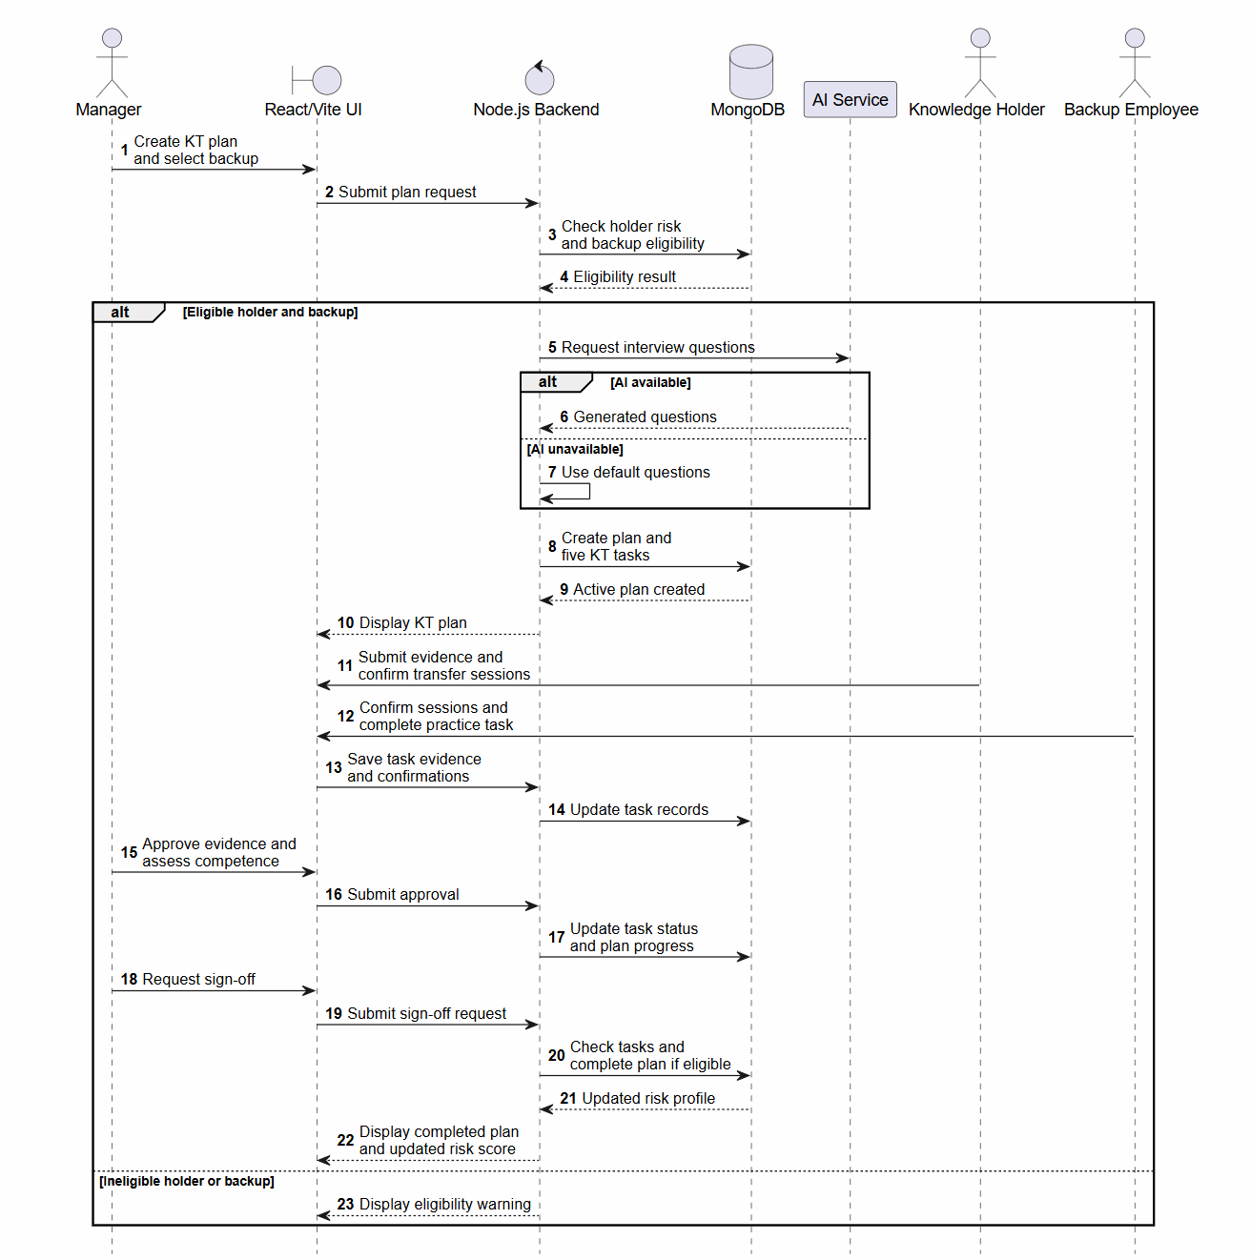
Figure 4.7: Sequence diagram for knowledge-transfer plan completion and sign-off.
Figure 4.7 shows how a current High- or Critical-risk case becomes a controlled transfer plan. The backend enforces holder and backup tier restrictions, records five task states, and checks prerequisites before sign-off. It also shows that AI-generated interview questions are optional: default questions are used if the external service is unavailable. The score update reflects recorded workflow evidence and competence review, not proven long-term knowledge retention.

4.5 Development and implementation procedure
Development began with the questionnaire import and indicator mapping, then added transparent scoring and manager review. A separate Python service supplied classifier and history-anomaly functions. KT planning added eligibility, evidence, confirmations, competence review and sign-off. Manager chat and notifications were added as supporting ways to inspect and act on these records. The system stores scores and task states so a case can be followed across these steps.
Implementation decisions followed the project scope. Google Forms supplied questionnaire collection; the application consumed a CSV export rather than hosting a general survey builder. The risk formula and response checks remained in Node.js so that ordinary assessment processing did not require model inference. The Python service handled supporting ML output. Because the default classifier learns labels produced by the same formula used in the application, its output cannot be presented as independent predictive evidence. The generative service proposes interview questions, while participants supply the actual knowledge and a manager judges the backup’s performance.

4.6 Evaluation plan
Evaluation followed the four objectives. For O1, collected colleague responses were checked for indicator mapping, tenure-based scoring and quality warnings. Ten pairwise responses were converted and aggregated for an exploratory AHP comparison; the group's CR and proposed weights were reported separately from the baseline configuration. Controlled matrices tested whether an inconsistent proposal leaves stored settings unchanged. The generated Q1-Q4 records checked repeated import and score history without representing follow-up of the colleagues. Neither the exploratory AHP result nor the controlled safeguard changed the scoring weights used in the other demonstrations.
Table 4.7: Evaluation measures and evidence required
Aspect | Measure or observation | Evidence to present
Assessment processing | Mapped inputs, scores, warning state | De-identified test inputs and outputs
AHP configuration | CR safeguard for a submitted matrix | Configuration screen and implementation test; not baseline-weight validation
KT controls | Eligibility, task states, sign-off and scoreDelta | Test cases with expected and observed response
Usability | Aggregate SUS mean and sample SD | Aggregate calculation and n = 10
Acceptance | Mean usefulness, ease and intention ratings | Item-level scale and n for each construct

The four quarterly questionnaire sets are summarized in Table 4.8. They retain the same four survey-derived indicators while changing the work context and wording. This design supports repeated assessment without treating the generated quarterly records as a real longitudinal cohort.
Table 4.8: Quarterly assessment questionnaire design
Quarter | Questionnaire context | Common design
Q1 | Routine workflows and day-to-day dependency | Ten questions mapped to EU, DG, PC and CD; includes reverse-worded checks
Q2 | Crisis, absence and service continuity | Same indicators and response scale; different incident-based wording
Q3 | Architecture, technical change and release risk | Same indicators and response scale; different system-design wording
Q4 | Knowledge-transfer readiness and cross-training | Same indicators and response scale; different handover and shadowing wording

For O2, the literature review compares the assessment and KT design with knowledge-loss and decision-support research. Its outcome is a justified design rationale, not a numerical performance claim. For O3, functional scenarios examined manager validation, score blending, service fallback, High/Critical KT eligibility, backup constraints, task creation, evidence and confirmation rules, approval gates, and sign-off recalculation. Each check was classified by its initial state, action, expected response, observed evidence, and evidence type. Chapter 5 separates visible interface results and executed unit tests from controls established only by source inspection.
For O4, ten system-evaluation questionnaires are scored with the standard ten SUS items [24]. Odd-numbered items contribute response minus 1, even-numbered items contribute 5 minus response, and the summed contribution is multiplied by 2.5 to obtain an individual 0–100 score. The mean and sample standard deviation summarize the ten individual scores. Acceptance items are summarized separately as mean Likert responses for perceived usefulness, perceived ease of use, and behavioural intention, reflecting constructs related to the Technology Acceptance Model [25]. Descriptive summaries are appropriate for this small convenience evaluation; they do not justify population estimates or a claim that the system was adopted by an organization.
Before completing the questionnaire, evaluators received the deployed-system link and the Google Form link through WhatsApp. They used the prototype independently to log in, view the dashboard and an employee risk profile, review manager validation, review or create a KT plan, and view AHP validation. They then completed the SUS and acceptance items. The three acceptance constructs remain separate from SUS and from functional correctness. Reporting the number of returned questionnaires beside each mean lets the reader judge the descriptive scope. The evaluation did not include a commercial-platform comparison or a controlled task-time study.
A KT example reports scoreDelta as final score minus previous score. A later-quarter value requires a separate generated assessment import. These outputs verify workflow arithmetic, not reduced organizational disruption. The study had no independent departure or retention labels for predictive validation. Non-functional qualities are reported only where a corresponding check exists.

4.7 Ethics and project management
The study used standalone colleague responses and start dates for Q1 mapping, and separate generated Q1-Q4 records for workflow demonstration. Questionnaire results are reported in aggregate. Manager chat sends team names, identifiers, tags and risk summaries to the configured external AI provider; email templates can contain names and risk tiers. The demonstration used fictional identities. Real organizational deployment would require consent or another appropriate basis, data minimization, provider review and retention controls before these functions process employee information. Risk tiers support continuity preparation, not employment decisions.
The project used an iterative development workflow described as Agile-Kanban to coordinate implementation and refinement. This practice did not constitute a controlled experiment. The questionnaire files contain responses but do not document participant recruitment, consent, or institutional ethics approval. Those procedures must be checked against the researcher’s records before submission; no organizational deployment or formal ethics approval is claimed on the basis of the available evidence.

4.8 Chapter summary
The methodology connects a design science study to available test data, expert comparisons, application code, technical scenarios, and evaluator responses. It specifies the scoring and transfer procedures while setting limits on what the evidence can establish. Chapter 5 reports the corresponding artefact and evaluation results.

5. RESULTS

5.1 Chapter overview
This chapter reports what KnowledgeGuard produced and what the available evaluation established. It presents assessment and knowledge-transfer outputs, functional verification, exploratory AHP findings, usability and acceptance responses, and saved machine-learning results. Collected colleague responses, generated workflow records and synthetic ML training profiles are reported separately. A working feature or a changed risk score is not treated as evidence that an organization retained knowledge after an employee transition.

5.2 Evaluation data
Five evidence sources contributed to the results. The 30 standalone Q1 responses from industry colleagues and their supplied start dates provided prototype inputs for questionnaire mapping and tenure calculation. A separate dataset of 120 generated records represented 30 fictional identities across Q1-Q4 and was used to demonstrate repeated imports and score history. Ten expert responses supplied exploratory AHP comparisons. Ten deployed-prototype evaluation forms supplied SUS and TAM ratings. The saved ML model and metrics documented training on 500 synthetic, formula-labelled profiles. The collected responses were not joined to the fictional quarterly identities.
Evidence source | Quantity | Result supported
Standalone colleague Q1 assessments | 30 responses | Assessment-input mapping and tenure calculation
Separate generated Q1-Q4 records | 120 records; 30 fictional identities | Quarterly import, history and workflow demonstration
Expert pairwise-comparison forms | 10 responses | Aggregated AHP weights and consistency
System-evaluation forms | 10 responses | Descriptive SUS and TAM summaries
Saved synthetic ML training record | 500 generated profiles | Internal metrics against formula-derived labels
Table 5.1: Evaluation sources and their interpretation boundaries
The available evidence does not include an independently retained import audit stating how many Q1 records were rejected or flagged. Those counts are not reported. The evaluator group was small, and exact role counts were not recorded.

5.3 Prototype outputs and workflow demonstration

5.3.1 Assessment and manager validation
KnowledgeGuard displays five indicator values, the transparent formula score, a supporting ML score, the final blended score, confidence information and the current risk tier. Figures 5.1 and 5.2 show the same synthetic demonstration record before and after manager validation.
Before validation, the displayed formula score was 9.7 and the ML support score was 6.2. The preliminary blend was 0.70(9.7) + 0.30(6.2) = 8.65, displayed as 8.7/10 and classified High. The manager component shown as 0.0 was not used in this preliminary blend. After the manager submitted validated values and a note, the displayed manager score was 10.0. The validated blend was 0.30(9.7) + 0.50(10.0) + 0.20(6.2) = 9.15, displayed as 9.2/10 and classified Critical. This comparison makes recorded human review visible; it is not a prediction that the employee will leave.
[Insert Figure 5.1 image here]
Figure 5.1: Preliminary risk profile for a synthetic demonstration record before manager validation.
[Insert Figure 5.2 image here]
Figure 5.2: The same synthetic risk profile after manager validation.

5.3.2 Knowledge-transfer planning and tasks
The plan-creation interface presents the knowledge holder, backup field, knowledge areas, priority and deadline. Knowledge tags guide proposed areas and help rank candidates. Figure 5.3 shows the creation form; an unselected backup field alone does not prove that an ineligible backup was rejected. The backend safeguard is reported separately in Table 5.3.
Once an eligible plan is created, the application records five task types: documentation, shadowing, structured interview, backup practice and competence review, and manager sign-off. Figure 5.4 shows an active plan with these stages initially pending. It demonstrates task creation, not completed transfer or successful sign-off.
[Insert Figure 5.3 image here]
Figure 5.3: Knowledge-transfer plan creation for a synthetic High- or Critical-risk case, showing knowledge-area guidance.
[Insert Figure 5.4 image here]
Figure 5.4: Five knowledge-transfer task types created for a synthetic demonstration plan.

5.3.3 Worked knowledge-transfer score trace
A separate arithmetic example makes the configured KT effect reproducible. It is not the employee shown in Figures 5.1 and 5.2. With EU = 9, DG = 8, PC = 9, CD = 7 and T = 10, the baseline formula gives F = 0.25(9) + 0.20(8) + 0.20(9) + 0.20(7) + 0.15(10) = 8.55. Using an illustrative manager score of 8.50 and ML support score of 6.50 gives R = 0.30(8.55) + 0.50(8.50) + 0.20(6.50) = 8.115, or 8.12 after rounding: High. The 6.50 value is an assumed input for this example and the maximum configured ML score available from the saved model's represented classes; it is not a captured prediction for this record.
In a simulated fully completed KT case, approved documentation reduces DG by 3, a fully competent backup rating reduces EU by 3, and approved shadowing and interview evidence reduce CD by 2. PC and tenure remain unchanged. The resulting values are EU = 6, DG = 5, PC = 9, CD = 5 and T = 10, producing F = 6.80. No post-sign-off final blended score is inferred: the application must recalculate its manager and ML components. A later-quarter history entry requires a separately imported generated assessment.
Stage | EU, DG, PC, CD, T | Formula score | Interpretation
Before KT | 9, 8, 9, 7, 10 | 8.55 | Arithmetic example; illustrative blended score 8.12
After stipulated approved tasks | 6, 5, 9, 5, 10 | 6.80 | Configured indicator update; not measured retention
Later quarter | Separate generated import | Calculated from new record | New demonstration history observation
Table 5.2: Simulated knowledge-transfer score trace

5.4 Functional verification and implementation evidence
Table 5.3 separates visible prototype outputs and executed utility tests from rules identified through source-code inspection. A source-inspected safeguard is not labelled as a passed end-to-end test. The controlled inconsistent AHP screenshot in Figure 5.5 is distinct from the expert-group result in Section 5.5.
Test | Expected function | Available observation | Evidence type
FT01 | Map assessment answers and calculate tenure | Mapping workflow available; accepted/rejected/flagged tally not retained | Controlled input and inspection; tally unverified
FT02 | Calculate preliminary score | Figure 5.1 shows formula 9.7, ML 6.2, final 8.7 and High tier | Visible UI result
FT03 | Record manager validation and recalculate | Figure 5.2 shows manager 10.0, note/status, final 9.2 and Critical tier | Visible UI result
FT04 | Reject inconsistent AHP input | Controlled CR 0.2000 disables Apply; three utility tests passed | UI and unit tests; API endpoint not executed
FT05 | Reject Low/Medium KT holder | Backend checks latest holder tier | Code inspection; runtime rejection not recorded
FT06 | Reject High/Critical backup | Client guidance and backend latest-tier rejection present | Code inspection; runtime rejection not recorded
FT07 | Create five KT task types | Figure 5.4 shows five pending stages | Visible UI result for task creation
FT08 | Block early sign-off and apply valid update | Sign-off and mitigation rules present | Code inspection; completion test not recorded
FT09 | Fall back when ML is unavailable | Scoring engine substitutes F for missing ML result | Code inspection; outage test not recorded
FT10 | Require confirmation for manager chat action | Confirmation controls and backend checks present | Code inspection; effectiveness not evaluated
FT11 | Support alerts and optional email | Alert and optional email paths present | Code inspection; delivery not verified
Table 5.3: Functional verification and implementation evidence
The current KT creation route checks the holder's latest High/Critical tier. It does not independently require a manager-validation flag before creating a plan. Manager validation is therefore an intended decision step rather than an enforced prerequisite.

5.5 AHP results
The ten expert forms used a scale on which 1 favoured the left indicator, 5 indicated equality and 9 favoured the right. After conversion to reciprocal ratios and geometric-mean aggregation, the group matrix produced lambda_max = 5.3682 and CR = 0.0822. Because CR < 0.10, the aggregated matrix met the configured consistency threshold. This does not establish that every respondent was individually consistent or that the proposed weights predict real knowledge loss.
Indicator | Baseline | Group AHP | Difference
Expertise uniqueness | 25.00% | 51.77% | +26.77 pp
Documentation gap | 20.00% | 12.72% | -7.28 pp
Project criticality | 20.00% | 14.78% | -5.22 pp
Collaboration dependency | 20.00% | 15.05% | -4.95 pp
Tenure | 15.00% | 5.67% | -9.33 pp
Table 5.4: Predefined baseline and exploratory AHP group weights
The proposed weights were not applied. The baseline was fixed for prototype evaluation, and consistency alone is not external validation against organizational outcomes. Applying the proposal after the demonstrations would change their scoring basis. The difference is reported as an exploratory finding for later organizational review.
A separate controlled matrix produced CR = 0.2000, which is inconsistent under the application threshold. Figure 5.5 shows that negative-control safeguard. It is not the ten-expert group result.
[Insert Figure 5.5 image here]
Figure 5.5: AHP interface rejecting a controlled inconsistent matrix with CR = 0.2000; the expert-group result was CR = 0.0822.

5.6 Generated quarterly score history
The generated Q1-Q4 records show how the application stores and displays repeated assessments for the same fictional identities. Figure 5.6 presents a selected demonstration history. These records are separate from the 30 standalone colleague Q1 responses and do not represent observed changes in real employees over four quarters. A score change in this history is not evidence that a KT plan reduced organizational knowledge loss.
[Insert Figure 5.6 image here]
Figure 5.6: Score history from the separate generated Q1-Q4 workflow dataset.

5.7 Usability and acceptance results
The ten evaluators' SUS scores had a mean of 89.50, sample standard deviation of 3.07, and range of 85.0-95.0. These values describe favourable perceived usability within this small group. They do not estimate usability across organizations or prove that every task was completed successfully.
[Insert Figure 5.7 image here]
Figure 5.7: Aggregate SUS results for ten evaluators, showing mean 89.50 and sample standard deviation 3.07.
The acceptance-item means were 4.43/5 for perceived usefulness, 4.53/5 for perceived ease of use, and 4.60/5 for behavioural intention. Behavioural intention was the highest descriptive mean. An intention rating is not evidence of sustained organizational use.
Measure | n | Result | Interpretation boundary
SUS | 10 | Mean 89.50; SD 3.07; range 85.0-95.0 | Perceived usability of this evaluator group
Perceived usefulness | 10 | Mean 4.43/5 | Perceived value, not measured performance gain
Perceived ease of use | 10 | Mean 4.53/5 | Perceived ease, not task-time performance
Behavioural intention | 10 | Mean 4.60/5 | Stated intention, not actual adoption
Table 5.5: System-evaluation questionnaire summaries
[Insert Figure 5.8 image here]
Figure 5.8: Mean TAM construct ratings from ten evaluators on five-point scales.

5.8 Supporting ML results
The saved default model was trained on 500 synthetic profiles labelled according to the baseline formula. Its recorded training accuracy was 0.9780, weighted F1 was 0.9781, and mean five-fold stratified cross-validation F1 was 0.8526 with standard deviation 0.0487. Cross-validation is the more useful internal performance summary, but both metrics concern reproduction of generated formula labels. Neither demonstrates predictive accuracy for real employee departures, disruption or knowledge retention.
Saved metric | Value | Interpretation
Training accuracy | 0.9780 | Fit to synthetic formula-labelled profiles
Weighted F1 | 0.9781 | Same synthetic-label setting
Cross-validation F1 | 0.8526 +/- 0.0487 | Internal variation across synthetic-data folds
Represented classes | Low, Medium, High | No Critical examples in saved model
Table 5.6: Saved machine-learning metrics and interpretation
Because the saved model lacks a Critical class, its probability-weighted score cannot exceed the configured High midpoint of 6.50. The formula and manager components can still produce a Critical final tier. KnowledgeGuard includes a route for retraining on manager-validated records, but the reported model was not trained on those records. Manager-scored labels remain judgement-based until compared with independently observed outcomes.

5.9 Results against the objectives
Objective | Result supported
O1 - Indicators and response-quality checks | Five indicators and transparent mapping implemented; warnings prompt review, not accusations of dishonesty
O2 - Literature-based requirements | Research informed scoring transparency, manager involvement, backup practice and KT stages
O3 - Integrated prototype | Scoring and validation states visible; five KT task types created; other controls have evidence levels in Table 5.3
O4 - Verification and evaluator feedback | Selected UI and unit-test evidence; favourable descriptive SUS and TAM responses from ten evaluators
Table 5.7: Results against the research objectives

5.10 Chapter summary
KnowledgeGuard demonstrated a connected prototype workflow from assessment and scoring to manager review and KT planning. The ten-expert AHP result was internally consistent but proposed weights different from the unchanged baseline. Ten evaluators reported favourable usability and acceptance ratings. Generated quarterly records, simulated KT reduction and synthetic ML metrics establish prototype behaviour within their stated limits; they do not establish real-world prediction or lasting knowledge retention. A subsequent discussion chapter is required to interpret these bounded findings.

REFERENCES
[1] I. Nonaka, “A dynamic theory of organizational knowledge creation,” Organization Science, vol. 5, no. 1, pp. 14–37, 1994, doi: 10.1287/orsc.5.1.14.
[2] L. Argote and P. Ingram, “Knowledge transfer: A basis for competitive advantage in firms,” Organizational Behavior and Human Decision Processes, vol. 82, no. 1, pp. 150–169, 2000, doi: 10.1006/obhd.2000.2893.
[3] A. Daghfous, N. T. Amer, O. Belkhodja, L. C. Angell, and T. Zoubi, “Managing knowledge loss: A systematic literature review and future research directions,” Journal of Enterprise Information Management, vol. 36, no. 4, pp. 1008–1031, 2023, doi: 10.1108/JEIM-05-2022-0171.
[4] R. Iftikhar and M. Rashid, “Knowledge loss and retention in interorganizational projects: Evidence from public transportation projects from Pakistan,” International Journal of Managing Projects in Business, vol. 18, no. 2, pp. 241–264, 2025, doi: 10.1108/IJMPB-09-2024-0210.
[5] M. S. Sumbal, A. Ključnikov, S. Durst, A. Ferraris, and L. Saeed, “Do you want to retain your relevant knowledge? The role of contextual factors in the banking sector,” Journal of Knowledge Management, vol. 27, no. 9, pp. 2414–2433, 2023, doi: 10.1108/JKM-02-2022-0128.
[6] A. R. Hevner, S. T. March, J. Park, and S. Ram, “Design science in information systems research,” MIS Quarterly, vol. 28, no. 1, pp. 75–106, 2004, doi: 10.2307/25148625.
[7] S. Durst and M. Zieba, “Mapping knowledge risks: Towards a better understanding of knowledge management,” Knowledge Management Research & Practice, vol. 17, no. 1, pp. 1–13, 2019, doi: 10.1080/14778238.2018.1538603.
[8] Microsoft, “Intro to file collaboration in Microsoft 365, powered by SharePoint,” Microsoft Learn, 2025. [Online]. Available: https://learn.microsoft.com/en-us/sharepoint/intro-to-file-collaboration. [Accessed: Sep. 24, 2026].
[9] Atlassian, “Use labels to organize content and attachments,” Confluence Cloud Support, n.d. [Online]. Available: https://support.atlassian.com/confluence-cloud/docs/use-labels-to-organize-your-content/. [Accessed: Sep. 24, 2026].
[10] ServiceNow, “Knowledge workflows,” ServiceNow Platform Documentation, Xanadu release, Aug. 1, 2024. [Online]. Available: https://www.servicenow.com/docs/r/xanadu/servicenow-platform/knowledge-management/r_KnowledgeWorkflows.html. [Accessed: Sep. 24, 2026].
[11] M. K. Ward and A. W. Meade, “Dealing with careless responding in survey data: Prevention, identification, and recommended best practices,” Annual Review of Psychology, vol. 74, pp. 577–596, 2023, doi: 10.1146/annurev-psych-040422-045007.
[12] E. Igoa-Iraola and F. Díez, “Procedures for transferring organizational knowledge during generational change: A systematic review,” Heliyon, vol. 10, no. 5, art. e27092, 2024, doi: 10.1016/j.heliyon.2024.e27092.
[13] M. Biron, K. Turgeman-Lupo, and O. Zaid-Dominik, “Contextualizing the usefulness of knowledge received from retiring employees: Leader behaviour and organisational culture,” Knowledge Management Research & Practice, vol. 22, no. 6, pp. 620–631, 2024, doi: 10.1080/14778238.2023.2297060.
[14] M. S. Sumbal, E. Tsui, S. Durst, M. Shujahat, I. Irfan, and S. M. Ali, “A framework to retain the knowledge of departing knowledge workers in the manufacturing industry,” VINE Journal of Information and Knowledge Management Systems, vol. 50, no. 4, pp. 631–651, 2020, doi: 10.1108/VJIKMS-06-2019-0086.
[15] SAP, “Overview of SAP SuccessFactors Succession Planning,” SAP Help Portal, n.d. [Online]. Available: https://help.sap.com/docs/successfactors-succession-and-development/implementing-and-managing-succession/succession-planning-with-sap-successfactors-succession. [Accessed: Sep. 24, 2026].
[16] APQC, “APQC’s Knowledge Loss Risk Matrix,” Sep. 17, 2025. [Online]. Available: https://www.apqc.org/resource-library/resource-listing/apqcs-knowledge-loss-risk-matrix. [Accessed: Sep. 24, 2026].
[17] N. Galan, “Knowledge loss induced by organizational member turnover: A review of empirical literature, synthesis and future research directions (Part I),” The Learning Organization, vol. 30, no. 2, pp. 117–136, 2023, doi: 10.1108/TLO-09-2022-0107.
[18] N. Galan, “Knowledge loss induced by organizational member turnover: A review of empirical literature, synthesis and future research directions (Part II),” The Learning Organization, vol. 30, no. 2, pp. 137–161, 2023, doi: 10.1108/TLO-09-2022-0108.
[19] P. R. Massingham, “Measuring the impact of knowledge loss: A longitudinal study,” Journal of Knowledge Management, vol. 22, no. 4, pp. 721–758, 2018, doi: 10.1108/JKM-08-2016-0338.
[20] T. L. Saaty, “Decision making with the analytic hierarchy process,” International Journal of Services Sciences, vol. 1, no. 1, pp. 83–98, 2008, doi: 10.1504/IJSSCI.2008.017590.
[21] L. Breiman, “Random forests,” Machine Learning, vol. 45, no. 1, pp. 5–32, 2001, doi: 10.1023/A:1010933404324.
[22] F. T. Liu, K. M. Ting, and Z.-H. Zhou, “Isolation forest,” in Proceedings of the 2008 Eighth IEEE International Conference on Data Mining, Pisa, Italy, 2008, pp. 413–422, doi: 10.1109/ICDM.2008.17.
[23] Q. He and Z. Yang, “Generative AI-driven knowledge management in manufacturing firms: A five-stage framework for dynamic knowledge optimization and digital innovation,” Journal of Knowledge Management, vol. 30, no. 4, pp. 1447–1467, 2026, doi: 10.1108/JKM-03-2025-0418.
[24] J. Brooke, “SUS: A quick and dirty usability scale,” in Usability Evaluation in Industry, P. W. Jordan, B. Thomas, B. A. Weerdmeester, and I. L. McClelland, Eds. London, U.K.: Taylor & Francis, 1996, pp. 189–194.
[25] F. D. Davis, “Perceived usefulness, perceived ease of use, and user acceptance of information technology,” MIS Quarterly, vol. 13, no. 3, pp. 319–340, 1989, doi: 10.2307/249008.

APPENDICES

Appendix A: Assessment questionnaire and indicator mapping
This appendix records the Q1 standalone questionnaire used to collect anonymised colleague responses for prototype input demonstration. It contains no request for names, email addresses, employer names, project names or confidential work information. Start Date was collected only to calculate the tenure indicator. The separate Q2-Q4 records used in this study are generated workflow-test data; they are not further colleague questionnaires and are not presented as real employee observations.
Table A.1: Q1 assessment questions and score mapping
No. | Question and response options | KnowledgeGuard mapping
1 | How many other people can complete your complex deliverables without calling you? 3+; 1-2; Nobody. | EU: 2; 6; 10
2 | How steep is the learning curve for a capable colleague? <1 month; 1-3 months; >6 months. | EU: 2; 6; 10
3 | Are step-by-step standard operating procedures available and current? Fully; Partial or outdated; Unwritten. | DG: 2; 6; 10
4 | What percentage of your tasks could a colleague finish using available documentation? >80%; 40-79%; <40%. | DG: 2; 6; 10
5 | If key deliverables stall for 48 hours, what is the likely impact? Minor; Noticeable; Critical. | PC: 2; 6; 10
6 | How strongly is the work connected to service continuity, compliance, revenue or customer delivery? Low; Significant; Mission critical. | PC: 2; 6; 10
7 | How often do colleagues halt work while waiting for your knowledge or decision? Rarely; 2-3 times per week; Daily. | CD: 2; 6; 10
8 | How many colleagues or teams depend on your clearance, approval or specialist input? 1-2; 3-5; 6+. | CD: 2; 6; 10
9 | A peer in my department could step in and complete my complex deliverables. Strongly agree to strongly disagree. | EU reverse item: 2; 6; 10
10 | Troubleshooting procedures for my work are published, current and searchable. Strongly agree to strongly disagree. | DG reverse item: 2; 6; 10

Items 9 and 10 are reverse-worded consistency checks. A response-quality flag identifies low variation or contradictions for manager review; it does not label a participant dishonest. Tenure is not a questionnaire item: it is calculated from Start Date using the system tenure rule.

Appendix B: AHP response conversion and configuration evidence
KnowledgeGuard accepts a reciprocal 5 x 5 AHP matrix and calculates proposed weights, CI and CR. The ten available pairwise-response forms were reprocessed using the corrected direction: 1 favours the left indicator, 5 indicates equality and 9 favours the right. Form answers 1-9 map to left/right ratios 9, 7, 5, 3, 1, 1/3, 1/5, 1/7 and 1/9. Each pair was aggregated using the geometric mean of ten converted ratios. Table B.2 reports the resulting group matrix to four decimals; calculations used full precision. No respondent identifiers or timestamps are reproduced.
Table B.1: AHP configuration rule
Control | Input | Decision rule | System response | Evidence boundary | Study configuration
Matrix structure | Reciprocal 5 x 5 comparison matrix | Positive entries, reciprocal pairs, unit diagonal | Invalid matrices rejected | Implementation and unit-test evidence | Baseline unchanged
Consistency check | Controlled matrix supplied to the AHP component | CR < 0.10 before application | Inconsistent proposal cannot be applied | Functional safeguard only | Baseline unchanged
Authorized application | Consistent proposed weights | User must select Apply | Weights change only after authorization | No application performed in this evaluation | EU 0.25; DG 0.20; PC 0.20; CD 0.20; T 0.15

The corrected group matrix gave lambda_max = 5.3682 and CR = 0.0822; Table 5.4 reports its proposed weights. The result was inspected but not applied to live scoring. The evaluated baseline remained EU 0.25, DG 0.20, PC 0.20, CD 0.20 and T 0.15. The controlled inconsistent matrix used in FT04 is separate from these expert responses.
Table B.2: Aggregated reciprocal AHP comparison matrix (n = 10).
Indicator | EU | DG | PC | CD | T
EU | 1.0000 | 5.2962 | 4.4364 | 5.3437 | 4.0039
DG | 0.1888 | 1.0000 | 1.0000 | 0.9429 | 3.0852
PC | 0.2254 | 1.0000 | 1.0000 | 0.8737 | 4.6689
CD | 0.1871 | 1.0605 | 1.1445 | 1.0000 | 4.5530
T | 0.2498 | 0.3241 | 0.2142 | 0.2196 | 1.0000

Appendix C: System Usability Scale and Technology Acceptance Model instruments
The deployed-system link and evaluation Google Form were shared with ten working professionals through WhatsApp. They independently logged in, viewed the dashboard and an employee risk profile, reviewed manager validation, reviewed or created a KT plan, viewed AHP validation, and then completed the questionnaire. The available evaluation record does not contain evaluator names, organization affiliations, or exact role counts; it describes professional experience in HR, team management, technical work, or organizational processes.
Table C.1: Evaluator task protocol
Step | Evaluator task | Evidence purpose
1 | Log in to the deployed prototype using the provided access details. | Confirms access to the evaluated artefact.
2 | View the dashboard and one employee risk profile. | Assesses transparency and readability of risk information.
3 | Review manager validation information. | Assesses visibility of human oversight.
4 | Review or create a knowledge-transfer plan. | Assesses KT workflow understanding.
5 | View the AHP configuration screen. | Assesses visibility of the future calibration control.

The questionnaire contained the ten SUS items, three Perceived Usefulness items, three Perceived Ease of Use items and one Behavioural Intention item. The construct mapping was PU = questions 11-13, PEOU = questions 14-16 and BI = question 17. Report aggregate results only: SUS mean 89.50 and sample SD 3.07; PU 4.43; PEOU 4.53; BI 4.60 (n = 10). Exclude respondent identifiers and timestamps.

